REHABILITATION MANAGEMENT GUIDELINES FOR WATER RESOURCES

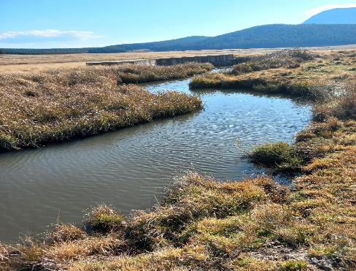
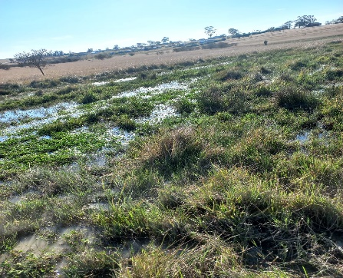
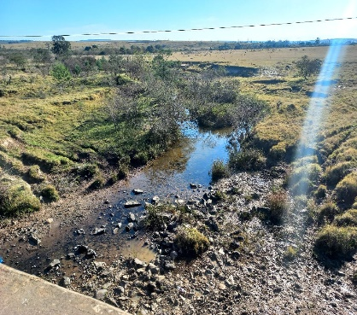
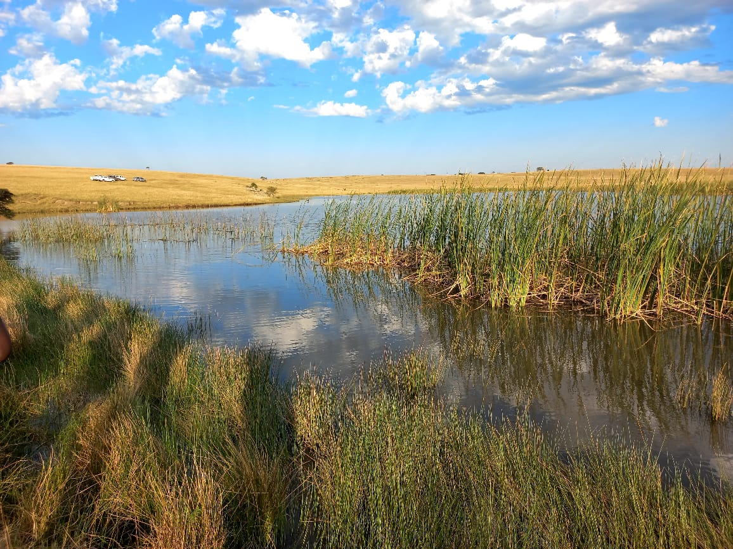
VOLUME 2: WETLANDS

July 2023
Version 4.5
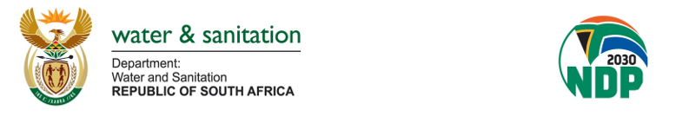

MAIN COVER PAGE:
The photos, on the document cover, were kindly supplied by Mr Lawrence Mulangaphuma of the
Department of Water and Sanitation.
Main photo (taken on 26 July 2022):
Photo taken in Msengeni village (Kommetjievlakte wetland), Eastern Cape Province
Wetland type and description: Marsh/floodplain wetland with channels.
Insert photo, bottom-left (taken on 27 July 2022):
Photo taken in Hanover (eDrayini wetland), Eastern Cape Province
Wetland type and description: Channeled valley bottom wetland
Insert photo, bottom-middle (taken on 27 July 2022):
Photo taken in Hanover, Eastern Cape Province
Wetland type and description: Marsh/Unchanneled valley bottom wetland
Insert photo, bottom-right (taken on 28 July 2022):
Photo taken in Hogsback (Hogsback wetland), Eastern Cape Province
Wetland type and description: Channeled Valley Bottom wetland

Mr Mulangaphuma is thanked for giving us permission to use his photos on the cover of this document.

Published by

The Department of Water and Sanitation
Private Bag X313
Pretoria, 0001
Republic of South Africa

Tel: (012) 336 7500/ +27 12 336 7500
Fax: (012) 336 6731/ +27 12 336 6731

Copyright Reserved

No part of this publication may be reproduced in any manner
without full acknowledgment of the source.

This report should be cited as:
Department of Water and Sanitation, 2022. Rehabilitation Management Guidelines. Rehabilitation Management Guidelines for Wetlands. Report 2.2. Sources Directed Studies. Report No: RDM/RMG/00/IHP/SDS/0222. Pretoria, South Africa

Document Index
REHABILITATION MANAGEMENT GUIDELINES FOR WATER RESOURCES
REPORT SERIES | REPORT TITLE | DWS REPORT NUMBER
- Project Planning Reports
1.1 | Project Plan | RDM/RMG/00/IHP/SDS/0120
1.2 | Gap Analysis Report | RDM/RMG/00/IHP/SDS/0220
1.3 | Framework Document | RDM/RMG/00/IHP/SDC/0121
1.4 | ToR for PSC members | RDM/RMG/00/IHP/SDS/0221
1.5 | Inception Report | RDM/RMG/00/IHP/SDS/0321
1.6 | Situation Assessment Report | RDM/RMG/00/IHP/SDS/0421
- Development of Rehabilitation Management Guidelines
2.1 | Rehabilitation Management Guidelines for Rivers | RDM/RMG/00/IHP/SDS/0122
2.2 | Rehabilitation Management Guidelines for Wetlands | RDM/RMG/00/IHP/SDS/0222
2.3 | Rehabilitation Management Guidelines for Estuaries | RDM/RMG/00/IHP/SDS/0123
2.4 | Rehabilitation Management Guidelines for Groundwater resources | RDM/RMG/00/IHP/SDS/0223
2.5 | Rehabilitation Management Guidelines for Lakes and Dams | RDM/RMG/00/IHP/SDS/0323
- Implementation Report
3.1 | Guidelines into Practice | RDM/RMG/00/IHP/SDS/0423
- Project Administration Reports
4.1 | Capacity Building Report | RDM/RMG/00/IHP/SDS/0523
4.2 | Stakeholder Engagement: Issues and Response Register | RDM/RMG/00/IHP/SDS/0623
4.3 | Technical Close-Out Report | RDM/RMG/00/IHP/SDS/0723

Departmental Approval
Authors: Mr Kgotso Mahlahlane, Dr Mampolelo Photolo, Ms Mmaphefo Thwala,
Mr Samkele Mnyango, Ms Tovhowani Nyamande
Contributors: Sub-Technical Task Team, Technical Task Team, Project Management
Committee, and Project Steering Committee
Project Name: Rehabilitation Management Guidelines for Wetlands
Report No: RDM/RMG/00/IHP/SDS/0222
Report Version: Version 4.5
Date: July 2023
_________________________________________________________________________________
Department of Water and Sanitation
Chief Directorate: Water Ecosystems Management

Recommended for Approval by:

……………………………………………..
Scientific Manager: Sources Directed Studies
Ms Mmaphefo Thwala (Project Manager)

Approved for DWS by:

…………………………………………….
Director: Sources Directed Studies
Ms Tovhowani Nyamande (Project Leader)

…………………………………………….
Chief Director: Water Ecosystems Management
Ms Ndileka Mohapi

Acknowledgments
DWS Project Administration Committee (PAC)
Ms | Tovhowani Nyamande | Director: Sources Directed Studies | Project Leader
Ms | Mmaphefo Thwala | Scientific Manager: Sources Directed Studies | Project Manager
Mr | Kgotso Mahlahlane | Production Scientist: Source Directed Studies | Project Coordinator
DWS Sub- Technical Task Team (Sub-TT)
Ms | Tovhowani Nyamande | Director: Sources Directed Studies | Project Leader
Ms | Mmaphefo Thwala | Scientific Manager: Sources Directed Studies | Project Manager
Mr | Kgotso Mahlahlane | Production Scientist: Source Directed Studies | Project Coordinator
Mr | Musawenkosi Kunene | Production Scientist: Strategy – Disaster Management | Member
Ms | Rachel Mpe | Production Scientist: Northwest Regional Office | Member
Mr | Samkele Mnyango | Production Scientist: Source Directed Studies | Member
Mr | Sazi Mthembu | Production Scientist: Resource Quality Information Services | Member
Dr | Stanley Nzama | Production Scientist: Reserve Determination - Groundwater | Member
Ms | Shaddai Daniel | Water Resource Management – Western Cape Regional Office | Member
Ms | Dikeledi Baloyi | Environmental Officer Specialised Production: Resource Protection and Waste | Member
Ms | Adaora Okonkwo | Scientific Manager: Water Resource Classification | Member
Ms | Joyce Machaba | Production Scientist: Reserve Determination-Surface Water | Member
Mr | Pieter Ackerman | Landscape Architect: Water Abstraction and In-Stream Use | Member
Ms | Nombuyiselo Mgca | Institutional Establishment – Eastern Cape | Member
Mr | Lindelani Lalumbe | Production Scientist: Surface and Groundwater Information | Member
Dr | Mampolelo Photolo | Resource Quality Information Services | Member

DWS Technical Task Team (TTT)

Ms | Tovhowani Nyamande | Director: Sources Directed Studies | Project Leader
Ms | Mmaphefo Thwala | Scientific Manager: Sources Directed Studies | Project Manager
Mr | Kgotso Mahlahlane | Production Scientist: Source Directed Studies | Project Coordinator
Mr | Elijah Mogakabe | Scientific Manager: Resource Quality Information Services | Member
Mr | Washington Tunha | Chief Engineer: Implementation Support – Micro Planning | Member
Ms | Thivhafuni Nemataheni | Scientific Manager: Water Use Efficiency | Member
Mr | Musawenkosi Kunene | Production Scientist: Strategy – Disaster Management | Member
Ms | Rachel Mpe | Production Scientist: Northwest Regional Office | Member
Mr | Samkele Mnyango | Production Scientist: Source Directed Studies | Member
Mr | Sazi Mthembu | Production Scientist: Resource Quality Information Services | Member
Dr | Stanley Nzama | Production Scientist: Reserve Determination - Groundwater | Member
Ms | Shaddai Daniel | Water Resource Management – Western Cape Regional Office | Member
Ms | Dikeledi Baloyi | Environmental Officer Specialised Production: Resource Protection and Waste | Member
Mr | Rendani Ndou | Control Environmental Officer: Resource Protection and Waste | Member
Ms | Adaora Okonkwo | Scientific Manager: Water Resource Classification | Member
Ms | Esther Lekalake | Production Scientist: Water Resource Classification | Member
Ms | Dephney Kabini | Planning and Information – Free State Regional Office | Member
Mr | Stanford Macevele | Institutional Establishment – Mpumalanga Regional Office | Member
Ms | Jeanette Nyama | Institutional Establishment – Gauteng Regional Office | Member
Ms | Mahadi Mofokeng | Deputy Director: Strategy Coordination | Member
Dr | Wietsche Roets | Specialist Scientist: Water Abstraction and In-Stream Use | Member
Ms | Abashoni Nefale | Deputy Director: Compliance Monitoring - Irrigation | Member
Mr | Tendamudzimu Rasikhanya | Director: Institutional Establishment | Member
Ms | Lumka Kuse | Production Scientist: Water Abstraction and In-Stream Use | Member
Ms | Morongwa Seko | Deputy Director: Compliance Monitoring & Enforcement | Member
Ms | Joyce Machaba | Production Scientist: Reserve Determination-Surface Water | Member
Mr | Pieter Ackerman | Landscape Architect: Water Abstraction and In-Stream Use | Member
Ms | Nombuyiselo Mgca | Institutional Establishment – Eastern Cape | Member
Mr | Lindelani Lalumbe | Production Scientist: Surface and Groundwater Information | Member
Dr | Mampolelo Photolo | Resource Quality Information Services | Member
Mr | Joseph Phasha | Control Engineering Technician | Member

DWS Project Management Committee (PMC)
Ms | Tovhowani Nyamande | Director: Source Directed Studies |  | Chairperson
Ms | Mmaphefo Thwala | Scientific Manager: Source Directed Studies |  | Project Manager
Mr | Kgotso Mahlahlane | Production Scientist: Sources Directed Studies |  | Project Coordinator
Mr | Samkele Mnyango | Production Scientist: Source Directed Studies |  | Member
Ms | Abashoni Nefale | Deputy Director: Compliance Monitoring - Irrigation |  | Member
Ms | Dephney Kabini | Planning and Information – Free State Regional Office |  | Member
Ms | Rachel Mpe | Production Scientist: Northwest Regional Office |  | Member
Mr | Stanford Macevele | Institutional Establishment – Mpumalanga Regional Office |  | Member
Ms | Jeanette Nyama | Institutional Establishment – Gauteng Regional Office |  | Member
Ms | Nombuyiselo Mgca | Institutional Establishment – Eastern Cape |  | Member
Ms | Khumbuzile Moyo | Scientific Manager: Water Use Efficiency |  | Member
Ms | Thivhafuni Nemataheni | Scientific Manager: Water Use Efficiency |  | Member
Mr | Kwazikwakhe Majola | Scientific Manager: Reserve Determination |  | Member
Mr | Lindelani Lalumbe | Production Scientist: Surface and Groundwater Information |  | Member
Ms | Lusanda Agbasi | Deputy Director: Sanitation Services Support |  | Member
Mr | Molefi Mazibuko | Production Scientist: Reserve Determination |  | Member
Ms | Mahadi Mofokeng | Deputy Director: Strategy Coordination |  | Member
Mr | Musawenkosi Kunene | Production Scientist: Strategy – Disaster Management |  | Member
Ms | Naomi Fourie | Scientific Manager: Compliance Monitoring - Afforestation |  | Member
Mr | Elijah Mogakabe | Scientific Manager: Resource Quality Information Services |  | Member
Mr | Sazi Mthembu | Production Scientist: Resource Quality Information Services |  | Member
Mr | Washington Tunha | Chief Engineer: Implementation Support – Micro Planning |  | Member
Mr | William Mosefowa | Deputy Director: Resource Protection and Waste |  | Member
Dr | Stanley Nzama | Production Scientist: Reserve Determination - Groundwater |  | Member
Ms | Joyce Machaba | Production Scientist: Reserve Determination-Surface Water |  | Member
Ms | Adaora Okonkwo | Scientific Manager: Water Resource Classification |  | Member
Mr | Fanus Fourie | Scientific Manager: Water Resource Planning Systems |  | Member
Ms | Shaddai Daniel | Water Resource Management – Western Cape Regional Office |  | Member
Ms | Esther Lekalake | Production Scientist: Water Resource Classification |  | Member
Mr | Tendamudzimu Rasikhanya | Director: Institutional Establishment |  | Member
Mr | Pieter Viljoen | Scientist Manager: Water Resource Planning Systems |  | Member
Dr | Wietsche Roets | Specialist Scientist: Water Abstraction and In-Stream Use |  | Member
Mr | Pieter Ackerman | Landscape Architect: Water Abstraction and In-Stream Use |  | Member
Ms | Dikeledi Baloyi | Environmental Officer Specialised Production: Resource Protection and Waste |  | Member
Mr | Rendani Ndou | Control Environmental Officer: Resource Protection and Waste |  | Member
Ms | Lumka Kuse | Production Scientist: Water Abstraction and In-Stream Use |  | Member
Ms | Morongwa Seko | Deputy Director: Compliance Monitoring & Enforcement |  | Member
Mr | Siyabonga Buthelezi | Scientific Manager – Kwazulu Natal Regional Office |  | Member
Ms | Nolusindiso Jafta | Deputy Director: Integrated Water Resource Management |  | Member
Mr | Isaac Ramukhuba | Environmental Officer Specialised Production: Water Use Licensing |  | Member
Mr | Michael Munzhelele | Environmental Officer Specialised Production: Water Use Licensing |  | Member
Mr | Bashan Govender | Mine Water Management |  | Member
Dr | Christa Thirion | Scientific Manager: Resource Quality Information Services |  | Member
Ms | Lerato Mokhoantle | Northern Cape Provincial Office |  | Member
Mr | Jaco Roelofse | Northern Cape Provincial Office |  | Member
Dr | Mampolelo Photolo | Resource Quality Information Services |  | Member
Mr | Joseph Phasha | Control Engineering Technician |  | Member
Project Steering Committee Members (PSC)
DWS Representatives
Ms | Tovhowani Nyamande | Director: Source Directed Studies |  | Chairperson
Ms | Mmaphefo Thwala | Scientific Manager: Source Directed Studies |  | Project Manager
Mr | Kgotso Mahlahlane | Production Scientist: Sources Directed Studies |  | Project Coordinator
Mr | Samkele Mnyango | Production Scientist: Source Directed Studies |  | Member
Ms | Barbara Weston | Scientific Manager: Reserve Determination |  | Member
Mr | Kwazikwakhe Majola | Scientific Manager: Reserve Determination |  | Member
Mr | Yakeen Atwaru | Director: Reserve Determination |  | Member
Ms | Adaora Okonkwo | Scientific Manager: Water Resource Classification |  | Member
Ms | Nolusindiso Jafta | Deputy Director: Water Resource Classification |  | Member
Ms | Lebogang Matlala | Director: Water Resource Classification |  | Member
Ms | Anet Muir | Director: Bulk Potable Water Pricing Regulation |  | Member
Ms | Abashoni Nefale | Deputy Director: Compliance Monitoring - Irrigation |  | Member
Ms | Dephney Kabini | Planning and Information – Free State Regional Office |  | Member
Ms | Rachel Mpe | Production Scientist: Northwest Regional Office |  | Member
Mr | Stanford Macevele | Institutional Establishment – Mpumalanga Regional Office |  | Member
Ms | Jeanette Nyama | Institutional Establishment – Gauteng Regional Office |  | Member
Ms | Nombuyiselo Mgca | Institutional Establishment – Eastern Cape |  | Member
Ms | Khumbuzile Moyo | Scientific Manager: Water Use Efficiency |  | Member
Ms | Thivhafuni Nemataheni | Scientific Manager: Water Use Efficiency |  | Member
Mr | Lindelani Lalumbe | Production Scientist: Surface and Groundwater Information |  | Member
Ms | Lusanda Agbasi | Deputy Director: Sanitation Services Support |  | Member
Mr | Molefi Mazibuko | Production Scientist: Reserve Determination |  | Member
Ms | Mahadi Mofokeng | Deputy Director: Strategy Coordination |  | Member
Mr | Musawenkosi Kunene | Production Scientist: Strategy – Disaster Management |  | Member
Mr | Elijah Mogakabe | Scientific Manager: Resource Quality Information Services |  | Member
Mr | Sazi Mthembu | Production Scientist: Resource Quality Information Services |  | Member
Mr | Washington Tunha | Chief Engineer: Implementation Support – Micro Planning |  | Member
Mr | William Mosefowa | Deputy Director: Resource Protection and Waste |  | Member
Dr | Stanley Nzama | Production Scientist: Reserve Determination - Groundwater |  | Member
Ms | Joyce Machaba | Production Scientist: Reserve Determination-Surface Water |  | Member
Mr | Fanus Fourie | Scientific Manager: Water Resource Planning Systems |  | Member
Ms | Esther Lekalake | Production Scientist: Water Resource Classification |  | Member
Mr | Pieter Viljoen | Scientist Manager: Water Resource Planning Systems |  | Member
Dr | Wietsche Roets | Specialist Scientist: Water Abstraction and In-Stream Use |  | Member
Mr | Pieter Ackerman | Landscape Architect: Water Abstraction and In-Stream Use |  | Member
Ms | Dikeledi Baloyi | Environmental Officer Specialised Production: Resource Protection and Waste |  | Member
Mr | Rendani Ndou | Control Environmental Officer: Resource Protection and Waste |  | Member
Ms | Lumka Kuse | Production Scientist: Water Abstraction and In-Stream Use |  | Member
Ms | Morongwa Seko | Deputy Director: Compliance Monitoring & Enforcement |  | Member
Mr | Bashan Govender | Mine Water Management |  | Member
Dr | Mampolelo Photolo | Resource Quality Information Services |  | Member
Dr | Christa Thirion | Scientific Manager: Resource Quality Information Services |  | Member
Mr | Isaac Ramukhuba | Environmental Officer Specialised Production: Water Use Licensing |  | Member
Mr | Michael Munzhelele | Environmental Officer Specialised Production: Water Use Licensing |  | Member
Mr | Siyabonga Buthelezi | Scientific Manager: Kwazulu Natal Regional Office |  | Member
Ms | Lerato Mokhoantle | Northern Cape Provincial Office |  | Member
Mr | Jaco Roelofse | Northern Cape Provincial Office |  | Member
Ms | Shaddai Daniel | Water Resource Management: Western Cape Regional Office |  | Member
Ms | Melissa Lintnaar-Strauss | Scientist Manager: Western Cape Regional Office |  | Member
Mr | Tendamudzimu Rasikhanya | Director: Institutional Establishment: Northern Cape |  | Member
Water Sector Representatives
Dr | Andrew Wood | Principal Scientist: SRK Consulting SA (Pty) Ltd |  | Member
Mr | Lehlohonolo Phadima | General Manager: Scientific Services: Ezemvelo KZN Wildlife |  | Member
Ms | Thembisa Torch | Assistant Director: DWS: Berg-Olifants Proto-CMA |  | Member
Dr | Eddie Riddell | Water Resources Manager: South African National Parks |  | Member
Mr | Ntsikelelo Wiseman Dlulane | Acting Chief Executive Officer: Ezemvelo KZN Wildlife |  | Member
Mr | Phil McLean | Task Manager: Western Cape Department of Environmental Affairs and Development  Planning, Pollution and Chemicals Directorate |  | Member
Mr | Stanley Tshitwamulomoni | Director: Water Sources and Wetlands Conservation |  | Member
Dr | Dhiraj Rama | Executive Director: Association of Cementitious Material Producers (ACMP) |  | Member
Mr | Kobus Fell | Advisor: National Water Monitor Non-Profit Company |  | Member
Ms | Thembela Bushula | Freshwater Ecologist: Breede-Gouritz Catchment Management Agency |  | Member
Mr | Donovan Gillman | President: Institute for Landscape Architecture in South Africa |  | Member
Mr | Reginald Mabalane | Policy Analyst: Mineral Council of South Africa |  | Member
Ms | Busisiwe Mahlangu | Control Environmental Officer: Inkomati-Usuthu Catchment Management Agency |  | Member
Mr | Sihle Ximba | Acting Water Care Manager: Ezemvelo KZN Wildlife |  | Member
Mr | Bonani Madikizela | Research Manager: Water Research Commission |  | Member
Ms | Elkerine Rossouw | Water Use Specialist: Breede-Gouritz Catchment Management Agency |  | Member
Ms | Hermien Oberholzer | Senior Principal Engineer: Anglo American Platinum |  | Member
Ms | Stephinah Mudau | Head Environment: Minerals Council of South Africa |  | Member
Mr | Matome Makwela | Senior Policy Analyst: Minerals Council of South Africa |  | Member
Ms | Jenifer Zungu | Project Leader: South African National Biodiversity Institute |  | Member
Mr | Douglas Macfarlane | Chief Scientist: Eco-Pulse Environmental Consulting Services |  | Member
Mr | Andre Beegte | Implementation Manager – Wetlands: Department of Forestry, Fisheries, and the Environment |  | Member
Ms | Debbie Muir | Biodiversity Officer Control: Department of Forestry, Fisheries, and the Environment |  | Member
Ms | Kate Snaddon | Senior Consultant: Freshwater Consulting |  | Member
Dr | Yolandi Schoeman | Postdoctoral Scientist and Ecological Engineer: University of the Free State |  | Member
Dr | Chantel Petersen | Senior Professional Officer: City of Cape Town |  | Member
Dr | Vhahangwele Masindi | Research and Development Manager: Magalies Water |  | Member
Ms | Kim Hodgson | Scientist – Water Quality Management: Umgeni Water |  | Member
Ms | Lilian Siwelane | Control Environmental Officer: DWS: North West, Institutional Management |  | Member
Mr | Mashudu Rafundisani | Senior Specialist - Catchment Management: City of Johannesburg Municipality |  | Member
Ms | Mpho Zwane | Senior Specialist - Water Quality Management: City of Johannesburg Municipality |  | Member
Ms | Esmeralda Ramburran | Deputy Director - Operational Support and Planning: Department of Forestry Fisheries and the Environment |  | Member
Mr | Norman Nokeri | Manager - Strategy and Planning: Lepelle Northern Water |  | Member
Mr | Pule Makena | Specialist - Catchment Management: City of Ekurhuleni Metropolitan Municipality |  | Member
Mr | Reveck Hariram | Senior Water Quality Advisor: Rand Water |  | Member
Mr | Theolin Naidoo | Senior Scientist: Institute of Natural Resources NPC |  | Member
Mr | Wiseman Ndlala | Senior Specialist - Water Quality and Catchment Management: City of Johannesburg |  | Member
Mr | Roger Bills | Senior Curator: South African Institute for Aquatic Biodiversity (SAIAB) |  | Member
Mr | Fazel Sheriff | Chief Engineer: Municipal Infrastructure Support Agent |  | Member
Mr | Themba Dladla | Provincial Programme Manager: Municipal Infrastructure Support Agent |  | Member
Dr | Kobus Du Plessis | Managing Director: Envirokonsult Scientific Services (Pty) Ltd |  | Member
Ms | Mulala Sundani | Environmental Impact Management: Department of Forestry, Fisheries, and the Environment (DFFE) |  | Member
Dr | Elizabeth Day | Director: Liz Day Consulting (Pty) Ltd |  | Member
Dr | Heidi van Deventer | Principal Researcher: Council for Scientific and Industrial Research |  | Member
Mr | Lubabalo Luyaba | Specialist – Water and Sanitation: South African Local Government Association |  | Member
Mr | Vhangani Silima | Coordinator Environmental Rehabilitation: Rand Water |  | Member
Ms | Phumelele Sokhulu | Environmental Officer: Umgeni |  | Member
Mr | Robert Siebritz | Senior Professional Officer: City of Cape Town |  | Member
Mr | Eddy Tshabalala | Control Environmental Officer: Sedibeng District Municipality |  | Member
Mr | Rodney February | MEL Coordinator: World Wide Fund for Nature |  | Member
Mr | Ruwen Pillay | Control Environmental Officer: Estuaries Management: DFFE |  | Member
Ms | Yolokazi Galada | Control Environmental Officer: DFFE |  | Member
Mr | Stephen Midzi | Manager: Biodiversity Conservation SANParks |  | Member
Dr | Thakane Ntholi | Manager: Water and Environment: Council for Geoscience |  | Member

List of Acronyms
AEWA  AMD  BAR  CARA  CD: WEM  CMA  DALRRD  DCOGTA  DEA  DEA&DP  DEDTEA  DFFE  DMA  DWAF  EA  ECA  EIS  EMP  EWR  DWS  EIA  GA  GIS  HIA  IDZ  IWQM  IWRM  M & E | The African-Eurasian Migratory Waterbird Agreement  Acid Mine Drainage  Basic Assessment Report  Conservation of Agricultural Resources Act  Chief Directorate: Water Ecosystems Management  Catchment Management Agency  Department of Agriculture, Land Reform and Rural Development  Department of Cooperative Governance and Traditional Affairs  Department of Environmental Affairs  Department of Environmental Affairs and Development Planning  Department of Economic Development, Tourism and Environmental Affairs  Department of Forestry, Fisheries and Environment  Disaster Management Act  Department of Water Affairs and Forestry  Environmental Authorization  Environment Conservation Act  Ecological Importance and Sensitivity  Environmental Management Plan/Programme  Ecological Water Requirements  Department of Water and Sanitation  Environmental impact Assessment  General Authorization  Geographic Information System  Heritage Impact Assessment  Industrial Development Zone  Integrated Water Quality Management  Integrated Water Resource Management  Monitoring and Evaluation
MPRDA  NDP | Mineral and Petroleum Resources Development Act  National Development Plan
NEMA  NEM: BA  NEM: WA  NEM: PAA  NFEPA | National Environmental Management Act  National Environmental Management: Biodiversity Act  National Environmental Management: Waste Act  National Environmental Management: Protected Areas Act  National Freshwater Ecosystem Priority Areas
NHRA  NVFFA | National Heritage Resources Act  National Veld and Forest Fires Act
NWA | National Water Act
NWRS | National Water Resource Strategy
NW&SMP  PES  RAM  REC  RQOs | National Water and Sanitation Master Plan  Present Ecological State  Risk Assessment Matrix  Recommended Ecological Category  Resource Quality Objectives
RDM  SA  SAHRA  SANBI  SWSAs  SFR | Resource Directed Measures  South Africa  South Africa Heritage Resources Agency  South African National Biodiversity Institute  Strategic Water Sources Areas  Stream flow reduction
SDCs  SDS  SPLUMA  WDCS  WML  WfWet  WULA  WUL  WRC | Sources Directed Controls  Sources Directed Studies  Spatial Planning and Land Use Management Act  Waste Discharge Charge System  Waste Management License  Working for Wetlands  Water Use License Application  Water Use License  Water Research Commission
WWTW | Wastewater Treatment Works

TABLE OF Contents
Document Index iii
Departmental Approval iv
Acknowledgments v
List of Acronyms xi
TABLE OF Contents xiii
List of Figures xv
List of Tables xv
executive summary xvi
1. INTRODUCTION 1
1.1 Background 1
1.2 wetland definition, Categories, and impacts 2
1.2.1 Definition of Wetlands 2
1.2.2 Wetland Characteristics and Indicators 2
1.2.3 Wetland Types and Categories 3
1.2.4 Wetland Ecosystem Services 5
1.2.5 Wetland Impacts 6
1.3 REHABILITATION DEFINITIONS and CONCEPTS 7
1.4 Purpose FOR DEVELOPMENT OF THE REHABILITATION MANAGEMENT 8
GUIDELINES FOR WETLANDS 8
1.5 GUIDING PRINCIPLES and approach FOR DEVELOPMENT OF THE GUIDELINES 8
1.5.1 Guiding Principles 8
1.5.2 Approach 9
1.6 INTENDED USERS of the guidelines 10
1.7 STRUCTURE OF THE GUIDELINES 10
2. LEGAL FRAMEWORK 11
2.1 OVERArCHING LEGAL FRAMEWORK 11
2.2 Other relevant legislative tools 15
2.3 ALIGNMENT WITH POLICIES, STRATEGIES and principles 16
3. CHARACTERISTICS OF WATERCOURSES 17
3.1 DEFINITION OF WATERCOURSES 17
3.2 INTRODucTION TO CHARACTERISTICS OF WATERCOURSES 17
3.3 LINK BETWEEN WATER RESOURCES AND CHARACTERISTICS OF WATERCOURSES 18
4. GUIDELINES FOR CHARACTERISTICS OF WATERCOURSES 19
4.1 hydrology 19
4.1.1 Components of the Hydrological Cycle 19
4.1.2 Definitions of the components of the Hydrological Cycle 20
4.1.3 Wetland Hydrology Impacts 20
4.1.4 Rehabilitation Management Guidelines for Hydrology 20
4.2 gEOMORPHOLOGY 29
4.2.1 Description 29
4.2.2 Factors Influencing Geomorphological Impacts 30
4.2.3 Rehabilitation Management Guidelines for Geomorphology 30
4.3 WATER QUALITY 32
4.3.1 Description 32
4.3.2 Types of Water Quality Impacts 32
4.3.3 Rehabilitation Management Guidelines for Water Quality 33
Consideration must be given to the passive treatment methods to include constructed wetlands and nature-based solutions. 36
4.4 HABITAT 38
4.4.1 Description 38
4.4.2 Types of Habitat Impact 38
4.4.3 Rehabilitation Management Guidelines for Habitat 38
4.5 BIOTA 41
4.5.1 Description 41
4.5.2 Types of Biota Impacts 41
4.5.3 Rehabilitation Management Guidelines for Biota 41
5. recommendations and way forward 44
Reference List 46
Appendices 49

List of Figures
Figure 1: Five main terrain unit indicators for wetlands landscape (DWAF, 2008) 2
Figure 2: Examples of soil forms as indicators of wetland presence (DWAF, 2008) 2
Figure 3: The seven primary HGM types for inland aquatic ecosystems and their typical landscape settings (Ollis et al., 2013) 4
Figure 4: Rehabilitation as part of the mitigation hierarchy for dealing with negative impacts on biodiversity (adapted from DEA et al., 2013) 7
Figure 5: Guiding Rehabilitation Steps (Adapted from Rountree and Batchelor, 2008) 9
Figure 6: The Ecological Water Requirements of the Reserve including drivers and responses (adapted from Beechie and Bolton, 1999). 18
Figure 7: Diagram depicting the link between water resources and characteristics of watercourses 19
Figure 8: Rehabilitation Inventions for erosion (headcuts) impacts. 23
Figure 9: Rehabilitation Interventions for straightened channel erosion. 23
Figure 10: Rehabilitation Interventions for channelled flow impacts. 24
Figure 11:Rehabilitation Interventions for structures impeding flow 24
Figure 12: Rehabilitation Interventions for peatland wetlands 25
Figure 13: Planning and Assessment Phase steps for alien vegetation control and clearing (adapted from WRC, 2016) 27
Figure 14: Alien vegetation clearing and control methods 28
Figure 15: Relationship between wetlands process, geomorphology, climate change and human activities (Tooth, et. al., 2015) 29
Figure 16: Interventions for addressing vegetation loss impacts. 31
Figure 17: Passive and Active Treatment Methods for rehabilitation of decanting opencast pit. 35
Figure 18: Weir structures available for wetland rehabilitation 43

List of Tables
Table 1: Landscape settings and flow characteristics of the HGM wetland types (adapted from Rountree and Batchelor, 2008) 3
Table 2: Ecosystem services included in, and assessed by, WET-EcoServices (WRC, 2008) 5
Table 3: Approach to be followed for development of Rehabilitation Guidelines for Characteristics of Watercourses 10
Table 4: Legislative Tools Applicable for Wetlands Rehabilitation 11
Table 5: Types of factors affecting wetland habitat 38

executive summary

There has been an increase in wetland rehabilitation interest and research efforts over the last two decades in South Africa.
In 2020, the Department of Water and Sanitation (DWS) Directorate: Sources Directed Studies (SDS) initiated an in-house project for the development of the Rehabilitation Management Guidelines (RMG) for Water Resources in South Africa. The project responds to one of the objectives of the Chief Directorate: Water Ecosystem Management to conduct sources directed studies. The project aims to address the fragmentation across different projects, programmes, and initiatives due to separate mandates and various institutions responsible for wetlands rehabilitation; especially with regard to characteristics of watercourses. It is for this reason that the DWS is developing Wetland RMG to address characteristics of watercourses, namely surface flow, groundwater flows, geomorphology, water quality, habitat, and biota through following a phased approach, namely; diagnostic, planning and assessment, setting of the rehabilitation objectives, execution, and monitoring phases. The following are key aspects covered to address the shortcomings of each characteristic of watercourse:
- Description of the specific characteristics of a watercourse;
- Types of impacts for each characteristic of a watercourse – a brief overview and description of the impacts that gives rise to the degradation of the watercourses to better understand the problem and subsequently develop effective rehabilitation guidelines;
- Legal Considerations - applicable legislation to be considered for undertaking site-specific rehabilitation activities on a particular characteristic of watercourse; and
- Development of Rehabilitation Guidelines - Step by step guidelines on rehabilitation measures/interventions for executing rehabilitation - planning, design, implementation, and monitoring.

The current Rehabilitation Management Guidelines (RMGs) for wetlands have been structured per characteristics of water courses, namely hydrology, geomorphology, water quality, habitat, and biota. Various activities impact on these characteristics of water courses in various ways within wetlands.

Erosion, alien vegetation clearing, over abstraction and road construction are the main impacts on the hydrology of wetlands. Grazing and trampling within the wetland modifies the runoff characteristics of the catchment and impacts upon the preferential flows of the wetland. Alteration of surface runoff result in straightened channel erosion and formation of gullies within the wetland due to higher-than-normal water velocity. Rehabilitation Management Guidelines for hydrology – surface flow and runoff have been developed with a focus on rehabilitation of altered and incised wetland channels due to erosion (gully and headcut) formation and alien vegetation.

Grazing in riparian areas within wetlands is a natural phenomenon, however, excessive grazing causes alteration of the natural vegetation cover, reduces vegetation and habitat complexity. These changes reduce the flood attenuation and sediment trapping efficiencies of wetlands. Other indirect effects of grazing include trampling within wetlands, and the creation of localised erosion gullies, while severely trampled riparian areas may be more vulnerable to erosion. The current RMGs have been developed for geomorphology with a focus on improving wetland vegetation growth and sediment trapping.
Water quality within wetlands is affected by both point sources of pollution and non-point sources of pollution. Point sources of pollution emanate mainly from industries, Wastewater Treatment Works (WWTWs) and other sources within the catchment. Inadequately treated effluent from WWTWs poses a risk to wetlands. Non-point sources of pollution are caused by activities such as mining, urban developments and agricultural return flows. Acid mine drainage (AMD) is one of the most serious and potentially enduring environmental problems for the mining industry. Rehabilitation Management Guidelines have been developed to address the discharge of raw and inadequately treated wastewater into watercourses.
In terms of Biota, human activities result in wetland habitat degradation and loss by altering water quality, quantity, and flow rates; pollutant increase; and species composition interference due to alien species introduction. Poor landscape planning/design practices, lack of development of scientific buffers, lack of protection of riparian habitat, overgrazing, and illegal harvesting for wood to make ornaments/furniture are amongst other impacts on habitat. RMGs have been developed to rehabilitate wetland habitat due to road construction/roadworks.
Human‐induced disturbance, such as the construction of barriers within or in close proximity of wetlands alters the hydraulics and geomorphic characteristics of the wetland. These barriers also alter the wetland aquatic zone which cause changes in the physical habitats upon which biota depend. RMGs have been developed for biota with specific reference to:
- Restoration of wetland conditions;
- Restoration of natural hydrological and sediment conditions; and
- Prevention of erosion headcuts and limitation of incisions within the wetland.

.

INTRODUCTION

Background
Wetlands in South Africa (SA) play an important role in sustaining the country’s ecology and economy through the indispensable ecosystem services they provide. These ecosystem services range from supporting a wide variety of specialised plant, insect, bird, and mammal life; to supplying wild food, grazing, building and craft materials to people; and absorbing flood waters, improving water quality and regulating streamflow, helping to maintain ecosystem functioning downstream. Different wetland types supply different ecosystem services (WRC, 2007; 2021). However, wetlands have been severely affected by the anthropogenic activities that have drastically altered landscapes over the past few centuries (Dini & Bahadur, 2016). It has been reported that more than 50% of wetlands have been lost in South Africa, and of those that remain, 33% are in poor ecological condition due to poor management (Nel and Driver, 2015). Furthermore, the latest National Biodiversity Assessment (NBA) Report (SANBI, 2019) also states that wetlands form part of the most threatened and least protected ecosystems in South Africa.
To integrate rehabilitation efforts on South African wetland systems, the Directorate Sources Directed Studies (SDS) within the DWS initiated a project for the development of RMGs (i.e., wetlands). The project responds to one of the objectives of the Chief Directorate: Water Ecosystems Management (CD: WEM) which is to conduct sources directed studies to ensure water resource protection.
In the Situation Assessment Phase of the project, it was established that a great deal of research has been conducted in South Africa to understand the discipline of wetland rehabilitation to provide locally and site-specific rehabilitation interventions. The impacts on wetlands were also clearly identified and contextualized for each of the studies reviewed. Below is a list of the main findings from the review conducted:
- The WRC Wetland Management Guidelines Series was the first of its kind to be developed in SA for effective wetland management and rehabilitation. Following various experiences gained in the application of wetland management and rehabilitation tools during the last ten years, the WET-Rehab Evaluate, WET-Health and WET-Eco Services were updated in 2019, 2020 and 2021 respectively. These guidelines provide technical methods for undertaking rehabilitation activities, the overarching legislative framework to consider for planning, designing, implementation and monitoring phases of rehabilitation interventions. In addition, the Buffer Zone Guidelines for Rivers, Wetlands and Estuaries (WRC, 2017) were developed for setting appropriate ecological buffers.
- There are also programmes and initiatives that are currently in place to ensure natural wetland rehabilitation improvement and management. A range of management options have been implemented to address the various impacts identified.
The Situation Assessment Phase concluded that the existing manuals and best practice guidelines suffice in protection and management of wetlands, with the below main gaps identified.
- Efforts across different Departments, projects, programmes, and initiatives are fragmented due to separate mandates and various institutions conducting rehabilitation work.
- Many wetland rehabilitation programmes do not address all characteristics of watercourses, as defined in the National Water Act, namely surface flow/surface runoff, groundwater flows, water quality, geomorphology, habitat, and biota.
- Most wetland studies/ programmes do not address the roles of constructed wetlands in the landscape.

wetland definition, Categories, and impacts
    - Definition of Wetlands
The National Water Act (NWA) (Act 36 of. 1998), defined a wetland as “land which is transitional between terrestrial and aquatic systems where the water table is usually at or near the surface, or the land is periodically covered with shallow water, and which land in normal circumstances supports or would support vegetation typically adapted to life in saturated soil”.
    - Wetland Characteristics and Indicators
There are several indicators and different site criteria that can be employed to identify wetland areas. The below four indicators have been developed to assist with the identification of wetlands (DWAF, 2008).
- Terrain Unit Indicator – assists with identification of those parts of the landscape where wetlands are more likely to occur. Figure 1 below illustrates the main terrain units.
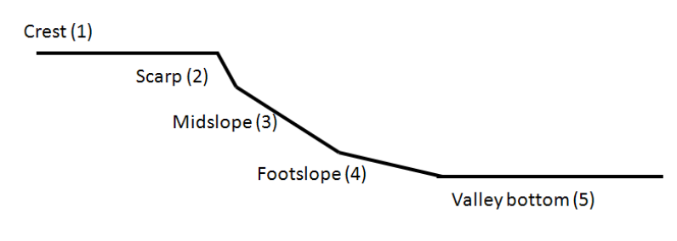
Figure 1: Five main terrain unit indicators for wetlands landscape (DWAF, 2008)
- Soil Form Indicator – aids to identify the type of soil form according to standard soil category system since wetlands are associated with certain soil types. Examples of soil form that are associated with wetlands are depicted in Figure 2.
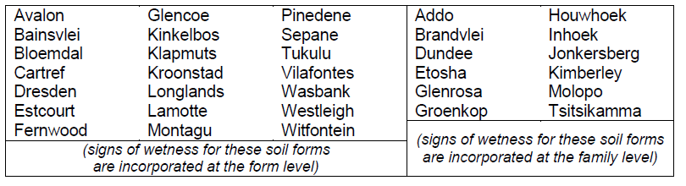
Figure 2: Examples of soil forms as indicators of wetland presence (DWAF, 2008)

- Vegetation Indicator – helps with identification of vegetation associated with ephemeral, seasonally and permanently saturated soils
- Soil Wetness Indicator- assists with identification of morphological signatures in soil profiles due to prolonged periods of saturation (i.e., anaerobic conditions).
    - Wetland Types and Categories
Different types of wetland areas exist in South Africa as a result of various environmental factors and topography. Cowan and Van Riet (1998) divided wetlands around the country into different regions according to climate and the geomorphology of the country. These are further sub-divided into four groups, i.e., mountains, plateau, coastal plain, coastal slopes and rimland. Endorheic pans, lacustrine, riverine, estuarine, palustrine, marine, and man-made/constructed wetlands are some of the most common wetlands found in South Africa.
Marneweck and Batchelor (2002) developed a system to characterise wetland systems based on the hydrogeomorphic (HGM) characteristics (landscape settings and flow) - the way in which water moves in, through and out of them. This system follows that used by the United States Environmental Protection Agency (US-EPA) and has in the past been included as part of a proposed wetland category system for South African wetlands by Ewart-Smith et al., (2006).
Table 1 below presents the different types of wetlands which are grouped according to landscape settings and hydrological functions.
Table 1: Landscape settings and flow characteristics of the HGM wetland types (adapted from Rountree and Batchelor, 2008)
Wetland Type | Description | Flow Pattern | Landscape setting
Rivers | - | Channelled | Valley bottoms | Strongly confined valley floor
Lakes | - | Standing water |  | Wide or unconfined valley floor
Unchannelled valley bottoms | - Valley bottom surfaces which do not have a channel;  - These systems tend to be found in the upper catchment areas, or at tributary junctions where the sediment from the tributary smothers the main drainage line | diffuse
Channelled valley bottoms | - Valley bottom surfaces which have a straight channel with flow on a permanent or seasonal basis;  - These systems tend to be found in the upper catchment areas. | Channelled (parallel to valley)
Meandering floodplain | - Valley bottom surfaces which have a meandering channel which develop upstream of a local (e.g. resistant dyke) base level, or close to the mouth of the river (upstream of the ultimate base level, the sea). | Channelled (meandering across valley)
Seepage wetlands | - Located on the mid- and foot slopes of hillsides; either as isolated systems or connected to downslope valley bottom wetlands. | Diffuse - diffuse | Slopes
 |  | Diffuse – surface/channel
Depressional Pans | - Pans are found in many arid zones around the world and consist of brackish, saline or alkaline lakes, flats, pans and marshes;  - Endorheic pans are distinguished by shapes ranging from circular to oval and have no drainage outlet;  - Pans are most frequently found in the Western, Southern and Eastern Plateau wetland regions of South Africa;  - Circular or oval in shape; usually found on the crest positions in the landscape. | Diffuse flow – standing water | Crests
Flats | - | No defined direction of drainage due to very flat landscaping | Flats

Thereafter, Ollis et al., (2013; 2016) publications were developed and used in the National Biodiversity Assessment (NBA) 2011 and 2018 for wetland ecosystem types; whereby seven primary HGM types (River, channelled valley-bottom wetland, unchanneled valley-bottom wetland, floodplain, depression, seep, wetland flat) are identified as the focal point of the SANBI classification system for inland aquatic ecosystems as depicted in Figure 3 below. These primary HGM types were derived from the HGM types recognized in the WET-Health tool for assessing the present ecological condition and WET-EcoServices tool for assessing the ecosystem services of palustrine inland wetlands in South Africa.
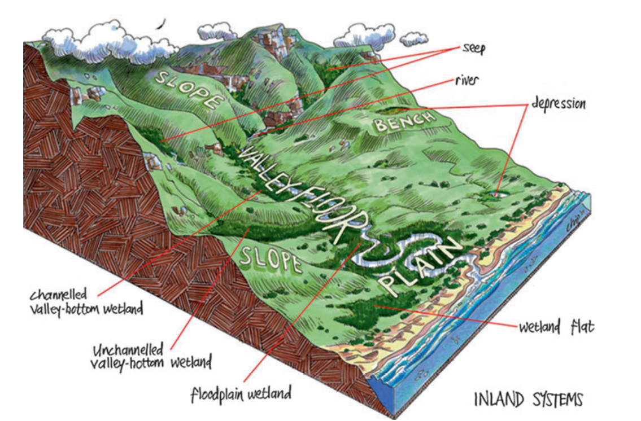
Figure 3: The seven primary HGM types for inland aquatic ecosystems and their typical landscape settings (Ollis et al., 2013)
    - Wetland Ecosystem Services
Wetlands are regarded as significant because of the beneficial services they provide. Table 2 below provides wetland services which have been detailed in the WET-EcoServices report compiled by WRC (2008; 2021) and they are considered most important for South African wetlands as described, which is by no means exhaustive. A rapid assessment technique referred to as the WET-EcoServices is a tool that was developed to monitor the importance of ecosystem services provided by different wetland ecosystem types and riparian areas in the country. The tool also informs decision making in relation to the prioritisation of wetlands for rehabilitation.
Table 2: Ecosystem services included in, and assessed by, WET-EcoServices (WRC, 2008)
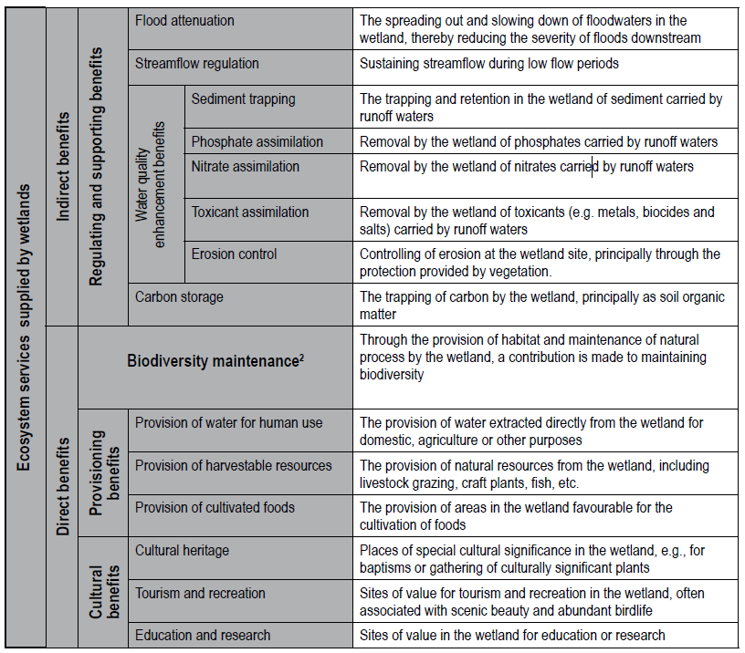
Other benefits include flood attenuation, stream flow regulation; water purification, provision of goods and services (i.e., food, medicine and building materials); biodiversity maintenance; recreational opportunities; and groundwater recharge and discharge; which may all be important but are difficult to characterise at a rapid assessment level.

    - Wetland Impacts

In 2014, approximately 300 000 wetlands were reported to make up 2.4% of South Africa’s surface area, excluding many wetlands that had already been irreversibly lost to a range of other land use activities (SANBI, 2014 and Driver et al., 2012). Of the nearly 800 wetland ecosystem types, 65% were threatened (likely to become endangered within the foreseeable future). Of this 65% wetland types, 48% were critically endangered (CR) (critical danger throughout all or a significant portion), 12% were endangered (EN) and 5% vulnerable (VU) (considered to be facing a high risk) (SANBI, 2014).
The latest mapping data in the recent NBA (SANBI, 2019) indicates that inland wetlands cover 2.2% of South Africa’s surface area; whereby the status persists, with an indication that “inland wetlands are highly threatened, with almost 80% of South Africa’s 135 inland wetland ecosystem types categorised as threatened (61% CR, 9% EN, 9% VU). When considered by extent, this amounts to almost 88% of South Africa’s estimated 2.6 million ha (26 000 km²) area for inland wetlands being threatened”.
Wetland ecosystems have been mapped according to types over the years ranging from National Wetland Map (NWM) versions 1 to 5; with each NWM providing improvements and updates to the spatial extent of the various wetland ecosystems. The update of the NWM5 showed that 2.2% of the country has been mapped as inland wetlands, totalling 2,6 million ha (Van Deventer et al., 2020).
The DWS monitors wetlands through the National Wetland Monitoring Programme (NWMP), the design of which was done through a WRC Project (completed in 2016). The NWMP is implemented by the DWS and seeks to assess and monitor the extent of wetlands, threats to, and the change in the present ecological state and ecosystem services provided by wetlands in the country. The Department of Forestry, Fisheries and Environment (DFFE) compiled Provincial Strategic Plans for 2019-2024 to address the identified impacts associated with wetlands per province. The most notable impacts in the literature include the following:
- Afforestation;
- Mining;
- Surface and groundwater abstraction;
- Agriculture;
- Siltation/Sedimentation of banks;
- Sewage discharge;
- Alien invasive species;
- Urbanization and Infrastructure development; and
- Industrial Development Zones (IDZs)
Depressions, particularly those around Gauteng, are being utilised as dumpsites during urbanisation. Afforestation alters the characteristics of the wetlands as well as the water supply that sustains the pans (Mackintosh et al., 2017). Conversely, pans located near farming are impacted upon by fertilisers and pesticides emanating from farming activities, which leads to water enriched with nutrients and eventually eutrophication.
Main threats to depression wetlands include industrial developments, recreational demands, and pollution from agricultural herbicides and pesticides (Cowan and Van Riet, 1998; Adame et al., 2019).

REHABILITATION DEFINITIONS and CONCEPTS
Rehabilitation refers to measures taken in the process of returning an impacted area to a desired ecosystem condition or structure, function, biotic composition, and associated ecosystem services (DWAF, 2008). Rehabilitation entails undertaking certain remedial action to minimise the adverse impacts on the environment and to prevent further environmental degradation from occurring, continuing, or recurring. Rehabilitation forms part of the logical sequence of the mitigation hierarchy for dealing with negative impacts on biodiversity and ecosystems (Figure 4). Rehabilitation requirements are most often implemented to address impacts that cannot be avoided or minimised for which there is well established guidance (Chamber of Mines, 2007), but may also be included as part of an offset requirement.
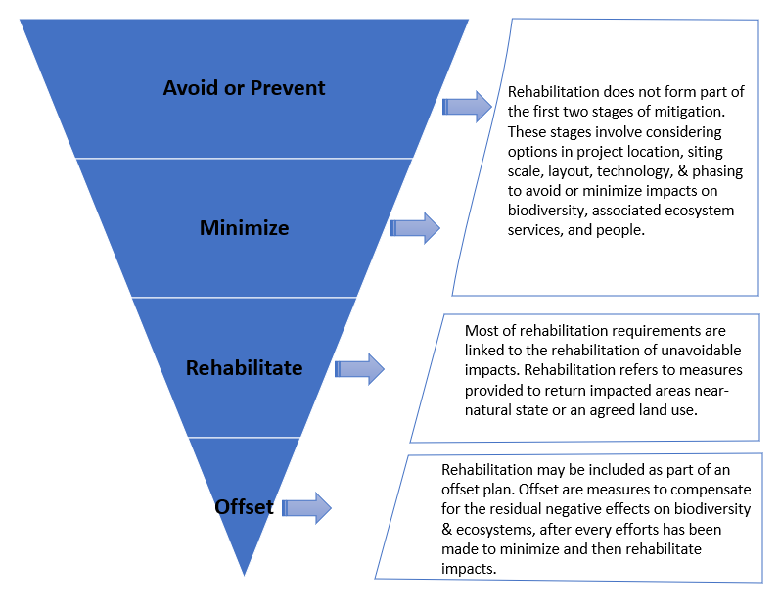
Figure 4: Rehabilitation as part of the mitigation hierarchy for dealing with negative impacts on biodiversity (adapted from DEA et al., 2013)

Wetland restoration is defined as remedial activity applied to systems that have been completely and permanently, but not irreparably, altered (Grenfell et al., 2007). Most recently, SANBI (2023) defined wetland restoration as “the process of assisting the recovery of an ecosystem that has been damaged, degraded or destroyed, towards an appropriate reference state”.

Wetland re-creation involves creating/establishing wetlands where they did not occur previously whilst Wetland re-establishment refers to where wetlands that were removed or lost by mining are re-established within the post mining or mining rehabilitation footprint. For the purpose of developing the current guidelines, wetland rehabilitation definition is adopted from Russel (2009); SANBI (2013); and DWS (2014) which refers to process of assisting recovery of a degraded wetland in terms of the wetland condition, function, and associated biodiversity, or in maintaining the health of a wetland that is threatened by degradation, through the implementation of remedial interventions or proactive preventative measures. See Appendix A for comparison between restoration, re-creation/re-establishment, and rehabilitation of wetlands.

Purpose FOR DEVELOPMENT OF THE REHABILITATION MANAGEMENT

GUIDELINES FOR WETLANDS

The primary objectives of the guidelines are to:
- Develop RMGs for Wetlands that address characteristics of watercourses, namely; hydrology, groundwater flows, geomorphology, water quality, habitat, and biota; and
- Integrate, align, identify existing wetland management bodies and standardize tools, processes, procedures, and rehabilitation strategies regarding wetland rehabilitation across various disciplines and institution.
  - GUIDING PRINCIPLES and approach FOR DEVELOPMENT OF THE GUIDELINES
The current RMGs are developed for characteristics of watercourses, namely; hydrology (surface flow and runoff), groundwater flows, geomorphology, water quality, habitat, and biota.
The following are aspects are covered under each characteristic of watercourse:
- Description of the specific characteristic of watercourse;
- Types of impacts for each characteristic of watercourse – brief overview and description of the impacts that gives rise to the degradation of the watercourses to better understand the problem and subsequently develop effective rehabilitation guidelines;
- Legal Considerations - applicable legislation to be considered for undertaking site-specific rehabilitation activities on a particular characteristic of watercourse; and
- Development of Rehabilitation Guidelines - Step by step guidelines on rehabilitation measures/interventions for executing rehabilitation - planning, design, implementation, and monitoring.

    - Guiding Principles
According to Rountree et al., (2007), guidance for rehabilitation planning can be applied in terms of rehabilitation context derived from the South African National Working for Wetlands Programme, a joint initiative of DFFE, DWS and Department of Agriculture, Land Reform and Rural Development (DALRRD). Some important aspects of guidance are provided in Figure 5 below.
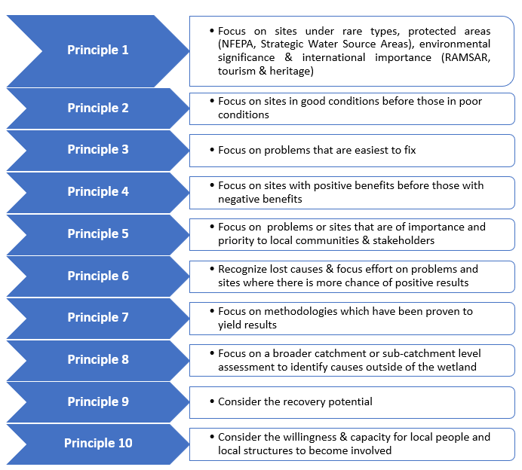
Figure 5: Guiding Rehabilitation Steps (Adapted from Rountree and Batchelor, 2008)
The need for rehabilitation arises due to degradation as reported by the National Water and Sanitation Master Plan, 2018. Although interventions may not be able to reinstate water resources to natural state, a functional state must be the aim of ecosystem recovery initiatives. King et al., (2003) recommended the following key principles for rehabilitation:
- Description of the specific characteristic of a watercourse;
- Types of impacts for each characteristic of a watercourse – brief overview and description of the impacts that gives rise to the degradation of the watercourses to better understand the problem and subsequently develop effective rehabilitation guidelines;
- Legal Considerations - applicable legislation to be considered for undertaking site-specific rehabilitation activities on a particular characteristic of a watercourse; and
- Development of Rehabilitation Guidelines - Step by step guidelines on rehabilitation measures/interventions for executing rehabilitation - planning, design, implementation, and monitoring.

    - Approach
The Wetland Rehabilitation Guidelines are developed with the aim to provide guidance to the water users on step-by-step rehabilitation measures/interventions to be followed for executing rehabilitation with specific attention to and consideration in planning, design, implementation, and monitoring of the identified impacts. Table 3 below presents the approach followed for development of the wetland guidelines.

Table 3: Approach to be followed for development of Rehabilitation Guidelines for Characteristics of Watercourses
Stakeholder Engagement
Phase | Description
PHASE 1: Diagnostic Phase | - The characteristics will be diagnosed to identify the cause/source of impact; determine the level of modification and rehabilitation measures will be recommended to reinstate the conditions of the drivers.  - Determine the conditions and the type, size, extent of impacts and vegetation cover/ species on characteristics of watercourses
PHASE 2: Planning & Assessment Phase | - Conduct planning and assessment to ensure the desired rehabilitation outcomes are achieved  - Assess and collate available information from maps & datasets on the affected watercourses  - Review and assess legal considerations
PHASE 3: Define the Rehabilitation Objectives | - Identify and define the objectives of rehabilitation to ensure the impacts on the characteristics of watercourses are addressed
PHASE 4: Execution | - Recommend techniques and methods to address impacts identified. Consider protection of water resources ecosystem
PHASE 5: Monitoring and Evaluation (M & E) | - Monitor the results of the techniques and methods employed for rehabilitation to determine whether objectives are being achieved and whether there are any additional interventions required  - Evaluate the effectiveness of interventions against achievement of rehabilitation objectives and outcomes  - Determine maintenance objectives
  - INTENDED USERS of the guidelines
The RMGs for Wetlands is a set of tools developed to ensure that clear and practical steps are provided on a wide range of rehabilitation measures/interventions related to characteristics of watercourses, which take cognisance of legal, ecological, social and economic issues and aspects. The guidelines are intended for all Government Departments (National, Provincial and Local), Catchment Management Agencies (CMAs), sectoral institutions (i.e., higher education institutions), civil society members, non-governmental entities, private sector (agriculture, industries, mining) and all interested and affected parties involved in the water sector. The guidelines are developed at a National scale for implementation at a Catchment scale/level.
  - STRUCTURE OF THE GUIDELINES
The guidelines are divided into six main sections as follows:
- The opening sections contain the document signatories, document index and status, acknowledgements, table of contents, list of figures, tables, acronyms, and executive summary
- Section 1 provides the background of the development of the guidelines, purpose, approach, intended users and structure of the guidelines
- Section 2 provides the overarching legal framework for wetland rehabilitation and alignment with key policies, strategies, and principles
- Section 3 describes the characteristics of watercourses and their linkage to water resources
- Section 4 provides the overarching water resource impacts and degradation impacts associated characteristics of watercourses and the step-by-step Technical Rehabilitation Guidelines for characteristics of watercourses
- Section 5 provides recommendations and way forward

LEGAL FRAMEWORK

OVERArCHING LEGAL FRAMEWORK
The Constitution of South Africa is the overarching legislative tool in the country, followed by sectoral legislation on environment and natural resource management. The South African government policy on wetlands recognizes that, in order to be truly effective, strategies for wetland conservation need to include a combination of proactive measures for maintaining healthy wetlands, together with actions to reverse past degradation. This latter aspect forms the core business of the government led wetlands programme. Different institutions lead the mandate over different legislative tools applicable to wetland rehabilitation; and the processes to be followed varies across institutions. Table 4 below presents a summary of institutions, legislative tools they administrate, and processes applicable to Wetlands Rehabilitation.

Table 4: Legislative Tools Applicable for Wetlands Rehabilitation
Overarching Legislative Tool
Constitution of the Republic of South Africa, 1996 (Act 108 of 1996)
Chapter 2, Section 24 provides that everyone has the right:
- To an environment that is not harmful to people’s health or well-being,
- To have the environment protected, for the benefit of present and future generations, through reasonable legislative and other measures that:
- prevent pollution and ecological degradation;
- promote conservation; and
- secure ecologically sustainable development and use of natural resources while promoting justifiable economic and social development.
Chapter 2, Section 27 provides that everyone has the right:
- To sufficient water.
Legislative Tools per Mandated Institution
Institution | Legislative Tool | Sections | Process
DWS | National Water Act, 1998 (Act 36 of 1998) | Chapter 3 provision for the Protection of Water Resources, with Part 4 and Section 19 pertaining to Pollution Prevention
 |  | 19, 20, 21, 39 | Water Use License Application (WULA), Waste Discharge Charge System (WDCS), General Authorization (GA)
 | GN 509 | 21(c) and (i) | GN509 allows water users to apply for Section 21(c) & (i) under a General Authorisation (GA), as opposed to a full WULA. These water uses may include general construction, maintenance and/or emergency work, river and stormwater management activities and undertaking wetland rehabilitation works within the regulated area of a watercourse. In order for a water use (or potential) to qualify for a GA under GN 509, the proposed water use/activity must be subject to analysis by a suitably qualified natural scientist that is professional registered with the South Africa Council for Natural Scientific Professions (SACNASP) using the DWS Risk Assessment Matrix (RAM).  Note: GN509 does not exempt the water user from compliance with any other provision of the Act or from any other applicable legislation, regulation, ordinance, or by-law.
 | GN 1198 | 21(c) and (i) | GN1198 relieves a water user from the need to apply for a license for impeding or diverting the flow of water in a watercourse in terms of section 21(c) or altering of the bed, banks, characteristics of watercourses in terms of section 21 (i) of the NWA for the purpose of rehabilitation, provided that the use is within the provision set out in the Notice.  Note: GN1198 does not exempt the water user from compliance with any other provision of the Act or from any other applicable legislation, regulation, ordinance, or by-law.  GA 1198 authorizes the Working for Wetlands Program and as a result, the DFFE does its submission in terms of that to DWS. This is the current approach that is followed by DFFE in order to obtain authorization
DALRRD | Conservation of Agricultural Resources Act, 1983 (Act 43 of 1983) | CARA is a substantial legal instrument for protecting wetlands and remains in force to this day; specifically, Section 6, 7, 12 | Application for consent  Section 12
DFFE | National Environmental Management Act, 1998 (Act 107 of 1998) | - Section 24N relating to EMPr  - Section 24P relating to financial provisions for remediation of environmental damage  - Section 30 and Section 30A relating to emergency incidents.  - 2014 EIA Regulations | EIA Regs, BAR, Environmental Management Plan/Programme (EMP)  Gazetted Environmental Management Programmes (EMPr)
 | National Environmental Management Act, 1998 (Act 107 of 1998) | - The ‘duty of care’ principle enshrined in section 28 of the NEMA requires landowners to take reasonable measures to prevent, minimize and rectify environmental degradation on their properties | - The WfWet programme also offers technical expertise to landowners and collaborates with local partners to set rehabilitation objectives with the intention of improving the integrity and functioning of ecosystems. Rehabilitation measures address both the causes and effects of degradation;
 |  | NEMA also formally regulates a number of activities that negatively impact the environment, including wetlands, through published lists of activities that require Environmental Authorization prior to such activities commencing, and the establishment of a regulatory application framework including Environmental Impact Assessments (EIA). Several listed activities are linked directly to activities within and in close proximity to wetlands | - EIA proceess
 | National Environmental Management: Biodiversity Act, 2004 (Act 10 of 2004) (NEM: BA) | - Section 57 relating to restricted activities in terms of ecosystems that are threatened or in need of protection  - Chapter 7 relating to permit requirements in terms of restricted activities.  - Stipulates that Municipal Integrated Development Plans at the local scale must align with the national biodiversity framework and bioregional plans  - Section 52 (1) (a) & (b) and 52(2) of the Act makes provision for the conservation of threatened ecosystems (i.e., including wetlands) in need of protection | Environmental Impact Assessment (EIA), Basic Assessment Report (BAR)  It establishes the South African Biodiversity Institute (SANBI) as the regulatory body on biodiversity and makes provision for several planning tools such as bioregional plans and biodiversity management plans
 | National Environmental Management: Protected Areas Act, 2003 (Act 57 of 2003) (NEM: PAA) | The purpose of the Act is to effect a national system of representative protected areas to preserve the country’s biodiversity, natural landscapes, and seascapes, including wetlands and wetland dependent species, and manage such areas in a sustainable manner
 | National Environmental Management: Waste Act, 2008 (Act 59 of 2008) (NEM: WA) | The Act regulates disposal of waste at the local scale and requires municipalities to obtain waste management licenses and develop an integrated waste management plan which has to be submitted to and approved by the relevant MEC. Thereafter the IWMP needs to be integrated into the municipality’s Integrated Development Plan. Through the regulations above, water resources are protected and dumping of waste along with a suite of other activities which may adversely impact on wetlands are prohibited.  45, Chapter 8 relating to the provisions on contaminated land. | Water Management License (WML), Licence in terms of section  45
 | National Environmental Management: Integrated Coastal Management Act, 2008 (Act. 24 of 2008) (NEM: ICMA) | The Act provides for various mechanisms to regulate activities in the coastal zone, including coastal wetlands situated within the zone. Where a wetland falls within the coastal protection zone, additional considerations are relevant in making a decision whether to grant an environmental authorization. Municipalities are also required to adopt coastal management programmes whilst the regulations for formulating estuary management plans are also stipulated.
 | Environmental Conservation Act, 1989 (Act.73 of 1989) (ECA) | This Act has been superseded by NEMA. Nevertheless, a Section 31A directive can still be enacted by the competent authority, local authority or government institution to legally instruct a person that is currently causing or has caused damage to the environment (including wetlands) to either cease the activity in question or take steps, within a period specified in the directive to eliminate, reduce or prevent the damage danger or detrimental effect.
South Africa Heritage Resources Agency  (SAHRA) | National Heritage Resources Act, 1999 (Act 25 of 1999) | Section 38 | Heritage Impact  Assessment (HIA)  Permit in terms of section 48
Department of Minerals Resources and Energy  (DMRE) | Mineral and Petroleum  Resources Development Act, 2002 (Act 28 of 2002) | Section 23, 27 | Permit in terms of section 27 or right in terms of section  23
Municipalities | By-laws | Sanitation, Land use Management and Waste Management by-laws | Applicable (per area) municipal by-laws need to be considered by every person(s) undertaking rehabilitation.

Note:
- The DWS GA 509 was published for 60 days Public Review with a due date of 9 May 2023. The GA makes provision for rehabilitation work in general that will enhance the PES of watercourses/ water resources. In general, the RMGs do not only concentrate on water use authorisations for new applications but also on historic activities that were undertaken without proper authorization.
- The DWS does not authorize rehabilitation, but it authorizes the impeding, diverting, or changing of bed/banks of characteristics of watercourses; and if any of those activities in terms of rehabilitation constitute those water uses, they need to get authorized accordingly.
- The RMGs provide guidance to other external persons (i.e., private) for any rehabilitation activities that may impede, divert, and change the bed/banks of characteristics of watercourses; if these other person(s) are impeding, diverting, and changing the bed/banks then they should apply for authorization for which there is a provision for within the DWS.

Other relevant legislative tools
- Spatial Planning and Land Use Management Act (No. 16 of 2013) (SPLUMA) – SPLUMA is the framework legislation regulating land use planning in South Africa and was developed to govern the planning permission and approval process, sets parameters for new developments and lists the various lawful land-uses in South Africa. Municipalities are required to plan and grant land use approval in line with the framework set out in SPLUMA. SPLUMA includes a number of key development principles which municipalities need to keep in mind during the regulation of land use and development within their jurisdictions. These principles should be integrated into the policies they develop for governance, specifically the integrated development plans developed by the municipality which must be aligned with SPLUMA and should include environmental components/considerations highlighted in environmental legislation. This provides opportunity for the incorporation of a wetland inventory layer into spatial development plans and land-use schemes at the local level providing an opportunity for important wetlands to be considered during the initial planning phase of any development.

- Disaster Management Act, 2002 (Act 52 of 2002) (DMA) – the Act focuses on avoiding or decreasing the risk of disasters, as well as dealing with emergency response planning and mitigation measures during and post-disaster through a coordinated cogent policy. It also requires national, provincial and municipal government institutions to compile disaster management plans at the appropriate scale, The importance of wetlands as critical ecological infrastructure which contributes to water quality enhancement and as part of buffering strategies against disasters such as droughts or floods should be integrated into these plans. Doing so could improve wetland management by elevating the importance of wetlands as a critical element of disaster management policy and implementation plans.

- National Veld and Forest Fires Act, 1998 (No. 101 of 1998) (NVFFA) – the purpose of the Act is to prevent and combat veld, forest, and mountain Fires throughout the Republic. It provides for a variety of institutions, methods, and practices to achieve its purpose. Where the burning of fire breaks includes burning reeds in wetlands, the requirements of this Act must also be complied with.

- National Heritage Resources Act, 1999 (Act 25 of 1999) (NHRA) – the Act aims to enable the provinces to establish heritage authorities which must adopt powers to protect and manage certain categories of heritage resources; to provide for the protection and management of conservation-worthy places and areas by local authorities; and. to provide for matters connected therewith.
- Environmental provisions of the Mineral and Petroleum Resources Development Act, 2002 (Act 28 of 2002) (MPRDA) to ensure that urban and commercial developments do not significantly affect or alter the natural state and function of wetlands.

- Municipal Systems Act, 2000 (Act 32 of 2000) (MSA) – the Act requires municipalities to develop a Spatial Development Framework which comprises a key component of their Integrated Development Plans. Integrated Development Plans are a legal requirement that consists of a comprehensive five-year plan which is revised annually for an area that gives an overall framework for development. The aim of an IDP is to improve interdepartmental coordination at the municipal level as well as between local, provincial, and national government through a holistic plan directed at improving the quality of living within the municipality in question. Within the Spatial Development Framework consideration should be given to the protection of valuable natural resources such as ecological corridors, agricultural land and wetlands. There is also an opportunity to include environmental projects in the IDP.

- Municipal by-laws
Municipal by-laws such as Sanitation, Land use Management, Waste Management, Stormwater Management and Diffuse Water Quality Management by-laws [applicable (per coastal area)] need to be considered by every person(s) undertaking rehabilitation.

ALIGNMENT WITH POLICIES, STRATEGIES and principles
Various policies and strategies inform Wetlands Rehabilitation Management in South Africa, and these include, but not limited, to the items:
Policies and Strategies
- National Development Plan (NDP)
- The National Water Resource Strategy (NWRS II) (2013)
- The National Water and Sanitation Master Plan (NW&SMP) (2018)
- The Integrated Water Quality Management (IWQM) Policies (2016) and Strategies for South Africa (2017)
- Eutrophication Management Strategy for South Africa – Second Edition (2022)
- The Draft Environmental Rehabilitation Policy (2014)
- National Biodiversity Strategy and Action Plan
- National Biodiversity Assessment
- National Freshwater Ecosystem Priority Areas (NFEPA)
- The implementation of Gazetted Resource Directed Measures (RDM), particularly the Reserve, Resource Quality Objectives (RQOs), Water Resource Classification and Sources Directed Controls (SDCs) as per principles of improving water resources quality and reducing deterioration where applicable
- Integrated Water Resource Management (IWRM)
- The Catchment Management Strategies as informed by the National Water Policy and promotes the sustainable balance between utilisation and protection of water resources in a catchment.

Principles
- Integrated Water Resource Management (IWRM)
- Sustainable Development Goals (SDGs)
- Social-Ecological System – consideration of water resources as socio-ecological systems.
- Chapter 1 of NEMA principles – guiding all organs of state regarding the approach they should have to environmental management (including wetland management). Section 2 (4) (a) (r) mentions wetlands specifically: “sensitive, vulnerable, highly dynamic or stressed ecosystems, such as coastal shores, estuaries, wetlands and similar systems require specific attention in management and planning procedures, especially where they are subject to significant human resources usage and development pressure”.

CHARACTERISTICS OF WATERCOURSES

DEFINITION OF WATERCOURSES
In terms of the definition contained within the National Water Act (NWA), Act 36 of 1998, a watercourse means:
- A river or spring;
- A natural channel which water flows regularly or intermittently;
- A wetland, dam, or lake into which, or from which, water flows; and
- Any collection of water which the Minister may, by notice in the Gazette, declare to be a watercourse; and
- A reference to a watercourse includes, where relevant, its bed and banks.

INTRODucTION TO CHARACTERISTICS OF WATERCOURSES
A comprehensive process of water resources rehabilitation requires attention to be given across the board for characteristics of watercourses, namely;
- Hydrology (surface flow and runoff)
- Geomorphology
- Water quality
- Habitat,
- Biota, and
- Groundwater flows.
For all the above-mentioned characteristics, rehabilitation of watercourses is limited. Generally, rehabilitation concerning shaping, re-vegetation, and alien eradication is limited under the NWA. Rehabilitation interventions and practices that focus and include water quality issues such as pollution from Wastewater Treatment Works (WWTWs) is also limited. There are multiple concerns around issues of rehabilitation and amongst these concerns are factors relating to mines, WWTWs as well as poor legislation in terms of buffers to watercourses. Therefore, the need for development of rehabilitation guidelines with a focus on characteristics of watercourses is enormous. To this end, to develop such guidelines, it is important to consider factors (drivers and responses) that underpin water ecosystem health and functionality. Figure 6 below depicts the Ecological Water Requirements (EWRs) components for ecosystems. This figure demonstrates that water flow, water quality and geomorphology are the main drivers of EWRs and the habitat (instream and riparian habitat) and biota (fish, aquatic, invertebrates, and riparian vegetation) being the responses but are interlinked.
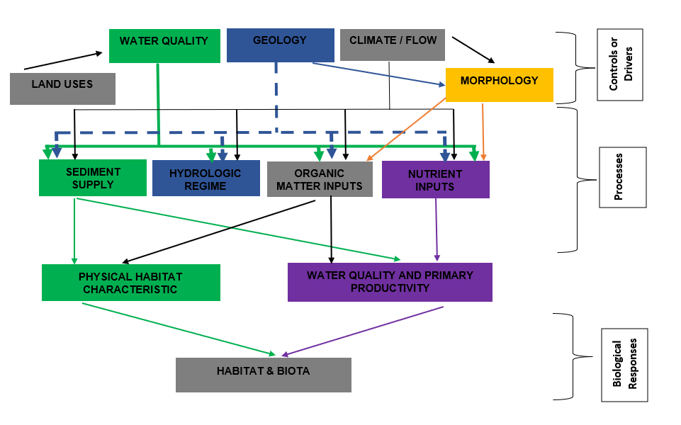
Figure 6: The Ecological Water Requirements of the Reserve including drivers and responses (adapted from Beechie and Bolton, 1999).

LINK BETWEEN WATER RESOURCES AND CHARACTERISTICS OF WATERCOURSES

The rehabilitation of water resources is directly linked to the rehabilitation of the characteristics of watercourses (drivers and responses) because impacts on water resources may be as equally prevalent on all these characteristics of watercourses. Figure 7 below illustrates the link between water resources and characteristics of watercourses.
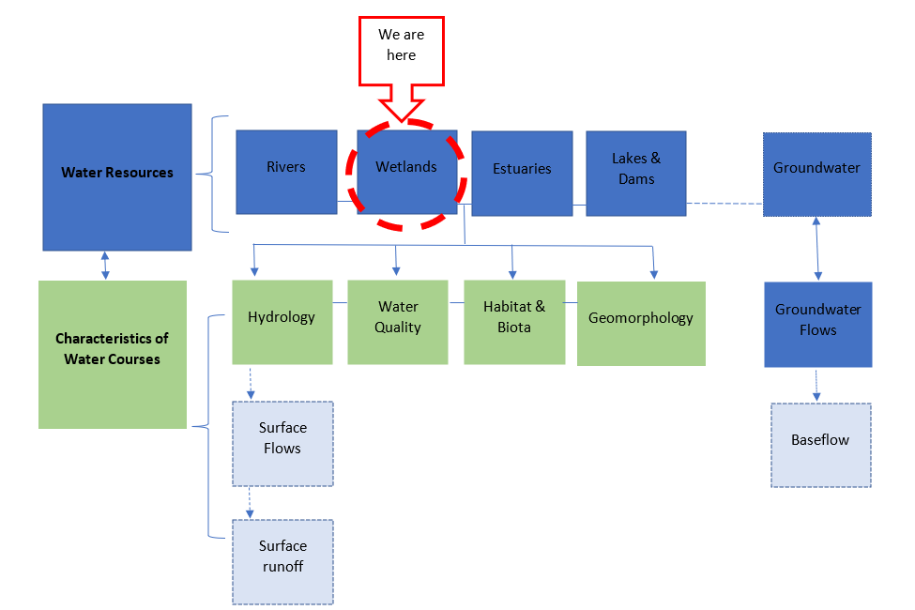
Figure 7: Diagram depicting the link between water resources and characteristics of watercourses

GUIDELINES FOR CHARACTERISTICS OF WATERCOURSES

hydrology
Hydrology is the science which deals with terrestrial waters, their occurrence, circulation and distribution on our planet, their physical and chemical properties, and their interaction with the physical and biological environment, including the effect on them of the activity of man (IHE,1998).
The hydrological cycle is the circulation of water within the earth's hydrosphere, involving changes in the physical state of water between liquid, solid, and gas phases and the exchange of water between atmosphere, land, surface, and subsurface waters. There is interaction between different components of the hydrological system and water movement and storage.
    - Components of the Hydrological Cycle
The hydrological cycle is divided into various components. These components are listed below, and they form an important part of the development of the guidelines:
- Direct rainfall;
- Surface flow and runoff;
- Interflow;
- Baseflow/Groundwater flow; and
- Stream flow.
    - Definitions of the components of the Hydrological Cycle
The below component of the hydrological cycle will be the focus of the guidelines. The component is described below as follows:
- Surface flow/surface runoff – total stream discharge of water, including all surface and subsurface flows derived from rainfall on a catchment surface, usually expressed in cubic metres of water yield per year.

    - Wetland Hydrology Impacts
Wetlands are important to local communities in terms of providing ecological services and goods. Important services provided by the wetlands are attributed to the wetland form, function, overall biodiversity and the system’s hydrology and its interactions to the catchment where it is located. These includes stream flow regulation, retention of sediment, nutrient trapping, and biodiversity maintenance. The hydrology of wetlands and their natural inter- and intra-annual hydrological regime cycle of their ecosystems are important. According to the NBA 2018 (SANBI, 2019), changes to the hydrological regime of inland wetlands negatively impacts their biodiversity with the potential to lead to ecosystem collapse. Water is the key driver of wetland formation, and it is essential to their functionality as many ecosystem services are attributed to the manner in which wetlands regulate water fluxes. However, various impacts modify wetland integrity and ecological connectivity, and these impacts are attributed to the following:
- Agricultural activities relating to extensive grazing and cultivation within the wetlands and the catchment in general. Overgrazing influences and modifies the runoff characteristics of catchment as well as other soil surface modification used in agriculture;
- Mining activities which destroy the wetlands or alter the wetland’s hydrological regime and water quality characteristics;
- Grazing and trampling within the wetland impacting upon the preferential flows within the wetland;
- The poor management of roads, fires, incision of the channel at places, sediment plumes and the diversion of water impacts the system’s hydrology;
- Surface runoff from road construction causes headcuts at the toe of wetlands;
- Alteration of surface runoff resulting in straightened channel erosion and formation of gullies within the wetland due to higher-than-normal flow velocity
- Over-abstraction and changes in flow drivers have a direct impact on ecological category, habitat, and biota;
- Poor Land Management practices such as agricultural practices interrupt flow paths and connectivity between wetlands and groundwater and other water resource components such as rivers, groundwater, and estuaries;
- Poor stormwater management around wetlands.

    - Rehabilitation Management Guidelines for Hydrology
The guidelines to be developed will address erosion (gully and headcut) formation within wetlands caused by (amongst others) the discharge of high water-velocity from management of roads; increased peak flows from upstream portions of the wetland; grazing and trampling which alter preferential flows.
SCENARIO 1: Rehabilitation of altered and incised wetland channels due to erosion (gully and headcut) formation
PHASE 1: Diagnostic Phase:
Step 1: Determine the areas within the wetland which are incised or impacted by erosion
Step 2: Identify and determine the causes of erosion
Step 3: At a desktop level, employ remote sensing to identify the areas impacted by erosion and their
extent. Soil erosion mapping can also be undertaken to ascertain the extent of the impact

PHASE 2: Planning and Assessment

Step 1: Conduct a site visit survey with the relevant specialists (i.e., Wetland Specialist, Engineer and
Environmental Assessment Practitioner) to:
- Describe the hydro-geomorphic setting and characteristic of the wetland impacted
- Assess the overall health of the wetland using WET-Health Guidelines (WRC, 2008; 2020)
- Identify the specific impacts to be addressed by rehabilitation and describe it in more detail where necessary. For example, for headcut erosion, the specific dimensions and level of activity of headcuts would be described.
- Field observation, describe in detail areas impacted and the type of erosion impacts observed. Below are some of the examples of erosion that might be prevalent:
- Sheet, rill, interrill or tunnel erosion
- Gully erosion;
- Headcut erosion;
- Donga erosion;
- Stream channel/bank erosion.
Step 2: Map and delineate the wetland impacted and clearly show the extent. This will inform the
rehabilitation methods or techniques to be employed
Step 3: Site layout, rehabilitation objectives together with the proposed interventions must be agreed
by the team upon completing the site visit. In selecting the interventions, consider the
following:
- Intervention option(s) selected must be the most appropriate to achieve the rehabilitation objectives
- Appropriate dimensions of the wetland locations must be measured in order to be able to design and calculate the bill of quantities for the interventions
Step 4: An Environmental Authorization (EA) inclusive of Environmental Impact Assessment (EIA) and
Basic Assessment Process must be lodged with the National Department of Forestry, Fisheries,
and Environment (DFFE) for rehabilitation activities in terms of the National Environmental Management Act (NEMA). Below is a list of some key supporting documentations for the application:
- Basic Assessment Report
- Wetland Assessment Report
- Rehabilitation Plan Report
- Designs and Interventions Report – the report must include the following:
- Hydrological assessment to inform the selection of the design flow to be applied to the intervention.
- Construction materials to be selected based on site specific criteria
- The intervention design demonstrating a plan view, a longitudinal section and front elevation at appropriate scales, and appropriate dimensions
- Bills of quantities calculated for the designs including cost estimates
Step 5: A Water Use License Application (WULA)/General Authorization (GA) must be lodged with the
Department of Water and Sanitation in order for certain wetland rehabilitation activities to
be undertaken. These activities include ‘impeding or diverting the flow of water in a
watercourse’ and ‘altering the bed, banks, course or characteristics of a watercourse’
where they are specifically undertaken for the purposes of rehabilitating a wetland for
conservation purposes. Below is a list of some key supporting documentations for the
applications:
- Wetland Delineation and Assessment Report - this report must clearly demonstrate the impacts on resource quality characteristics (impact/modification to flow regime as ecosystem drivers); the proposed rehabilitation interventions and the possible changes to PES and EIS of the wetland system
- Environmental Impacts Assessment Report

Note: No wetland rehabilitation work may be undertaken until such time that an EA and WUL/GA is granted by the DFFE and DWS respectively.

PHASE 3: Identify & Define the Rehabilitation Objectives
The objectives of rehabilitation will entail addressing the incised wetland using the appropriate measures. These objectives must be informed by the information and data collated in Phase 1 and 2 above. As an example, when the primary threat to the wetland was identified as headcut erosion threatening to propagate through the wetland; the appropriate rehabilitation objective would be to halt and prevent the propagation of the erosion headcut using various methods/techniques.

PHASE 4: Execution
Step 1: Employ the appropriate rehabilitation methods or techniques (Figure 8-12) informed by the
submitted and approved Designs and Interventions Report (refer Phase 2 to see what the
report entails)
Step 2: Employ one or a combination of the below available soft and hard engineering interventions
(Note: these examples and guidance are informed by local knowledge acquired from the
Working for Wetland Programme Rehabilitation Interventions applied in South Africa.

Hillslope seepage
Figure 8: Rehabilitation Inventions for erosion (headcuts) impacts.

Channelled valley bottom

Figure 9: Rehabilitation Interventions for straightened channel erosion.
Unchannelled valley bottom

Figure 10: Rehabilitation Interventions for channelled flow impacts.

Floodplain

Figure 11:Rehabilitation Interventions for structures impeding flow

Peatlands
Figure 12: Rehabilitation Interventions for peatland wetlands

Notes:
Although the above intervention types and structures are packaged according to various wetland types, the main factor informing and dictating the most suitable intervention is the type of impacts prevalent on site. Below is a list of some commonalities observed across the various recommended interventions regardless of the type of wetland in question:
- Structures such as gabions, berms and weirs are suitable for diverting or redistributing water to more natural flow paths, or for the prevention of erosion by unnatural flow rates that result from unsustainable land use practices or development;
- Concrete and gabion weirs act as settling ponds which reduce flow velocity or re-disperse water across former wetland areas thereby re-establishing natural flow paths;
- Concrete or gabion structures stabilise headcut or other erosion and prevent gullies;
- Earth or gabion structure plugs are best suitable for raising channel floors and reduction of water velocity;
- Concrete and/or reno mattress strips are best suited for road crossings to address channels and erosion in wetlands;
- Natural engineering designs like groyns, rock mattress at angles, appropriate size rip rap, geotextiles, topsoil, vegetation is preferred above concrete and vertical placed gabion baskets.

PHASE 5: Monitoring and Evaluation
Monitoring
Undertake routine and systematic inspection of the rehabilitated wetlands to determine whether the conditions are improving or further degrading. The following are some of the parameters/variables to be monitored depending on the impacts:
- Water levels across the site – wetland hydrology function
- Habitat conditions
Evaluation
- Evaluate the effectiveness of interventions against the achievement of rehabilitation objectives and outcomes
- Determine maintenance objectives
Additional management measures must be implemented in the event the conditions do not improve.
SCENARIO 2: Control and clearing of Invasive Alien Species from wetlands and their immediate catchments to reduce water uptake from wetlands
PHASE 1: Diagnostic Phase
Step 1: Identify the areas within the wetland that are invaded by invasive alien species.
Step 2: At a desktop level, employ available tools such as Google Earth/Engine, satellite images, GIS,
QGIS ArcMap, and Remote Sensing to identify the areas within the wetland which is invaded
i.e., invasion of alien species along the channel of a wetland.
Step 3: Using information obtained from Google Earth satellite images and Remote Sensing as
ground truthing to describe in detail the zone within the wetland that is affected in terms of
the following:
- Species types i.e., woody alien vegetation;
- Density and the zone within the wetland into which invasion occurs.
- Visual description of the zone affected;
- The conditions upstream or downstream of the affected wetland zone.

PHASE 2: Planning and Assessment
Step 1: Conduct a site visit survey to accurately confirm and ascertain the preliminary findings
acquired in Phase 1. Below are some important aspects to consider when undertaking
fieldwork pertaining to observation made for the wetland in question:
- Photographs and GPS co-ordinates;
- Fixed-point photography (in accordance with the guidelines outlined in WET-Rehab-Evaluate: Cowden and Kotze, 2008);
- WET-Health information (allowing the comparison of wetland ecological integrity before and after rehabilitation activities); and
- Details relating to the calculation of estimated hectare equivalents affected.
- Species growth form (i.e., tree, seedling or creeper);
Step 2: The below summarised list of steps (Figure 13) must be considered during the planning and
assessment phase of alien vegetation clearing. These steps are adapted from WRC (2016) and
applied when undertaking clearing of alien vegetation for rivers but can equally be
applicable for clearing of alien species invading wetlands.
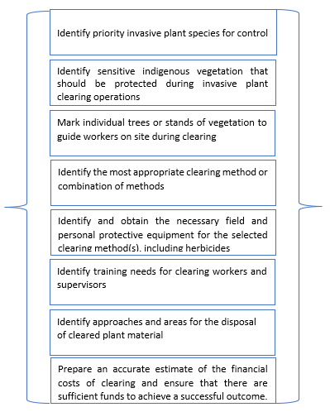
Figure 13: Planning and Assessment Phase steps for alien vegetation control and clearing (adapted from WRC, 2016)
PHASE 3: Identify & Define the Rehabilitation Objectives
The objectives of rehabilitation of alien vegetation must be defined and be clear at the start. These objectives must be informed by the information and data collated in Phase 1 and 2 above. Below is a list of common aims and objectives:
- To improve biodiversity by allowing the establishment / generation of natural indigenous wetland flora;
- To increase space for flood alleviation by clearing vegetation to increase the conveyance or the natural flow of water;
- To rehabilitate a more natural wetland flow regime by releasing trapped sediments and allowing erosion processes to restore natural river levels.

PHASE 4 – Execution:
Alien vegetation clearing and control methods are divided into three main categories, namely physical (or mechanical) control, chemical control, and biocontrol (Figure 14). A combination of these approaches may be implemented for the clearing and control of invasive plant species. These methods must be supported by a Plant Species Plan developed by a landscape architect or botanist.

Figure 14: Alien vegetation clearing and control methods

PHASE 5 – Monitoring and Evaluation
Monitoring
Monitoring of rehabilitated areas must be undertaken to:
- Ensure that treatment methods employed are adequate and effective to ensure that no additional measures are required;
- Allow learning from past practices, so that ongoing invasive alien plant clearing initiatives are constantly improving and are in accordance with seasonal changes.
The following monitoring suggestions are recommended by WRC (2016):
- A fixed-point photographic record should be collected, showing the affected wetland before, during and at regular time periods after initial alien clearing has taken place;
- Historical Google Earth images should be used over time, to provide a spatial record of clearing extent and effects;
- Monitoring using tools such as remote sensing and GIS.
Note:
Alien vegetation must be replaced with the appropriate indigenous vegetation. This is especially important when trees are removed, indigenous tree species must be brought in. Furthermore, alien management must be in a phased approached both eradication (to manage re-growth) and revegetation (to ensure growth success).

Evaluation
- Evaluate the effectiveness of interventions against the achievement of rehabilitation objectives and outcomes
- Determine maintenance objectives

gEOMORPHOLOGY

Description
Geomorphology is a science focused on understanding Earth surface processes and landscape (such as wetlands, mountains, valleys, river channels and estuaries) evolution (Keller, et.al., 2020). It is also regarded as the study of physical features on the earth and their relation to geological structures. Geomorphological understanding is central to environmental flows because it is the interaction between flow, form, and substrate that influences habitat type, condition, availability and biotic use across space and time (Meitzen et. al., 2013).
The long-term geomorphological evolution is strictly controlled by the interplay of tectonic activity and climate changes, and close to coastal zones, sea-level oscillations also contribute to modifying this natural system, as well as anthropogenic activities which also contribute to the modification of wetlands ecosystems.
Wetlands are key components of many landscapes worldwide and are regarded as providing a wide range of direct and indirect socio-economic services to the human beings. Hence, understanding how wetlands are structured, how they function and how they may change is important. It is therefore very important to note that the geomorphology of wetlands is an important aspect that needs to be considered when doing wetland rehabilitation. Figure 15 below is an illustration of the relationship between wetlands process, geomorphology, climate change and human activities.
Figure 15: Relationship between wetlands process, geomorphology, climate change and human activities (Tooth, et. al., 2015)

Factors Influencing Geomorphological Impacts
Scale is an important consideration, with process-form interactions occurring over a huge range of space (spatial scale) and time (temporal scale) (Charlton, 2008). The two considerations for management that come from geomorphology is time and space. Soil erosion is a major environmental problem that is associated with geomorphology. Such that, once the topsoil has been removed, the lower soil layers are exposed. These layers have poor structure and are low in organic matter and nutrients, as a result they are less permeable leading to increased overland flows which increases the sedimentation supplied to wetlands (Freeman and Rowntree, 2005).
Human interventions on the other hand have had an influence on modification of wetland systems for many years. Activities such as scouring of the channel bed deepens the channel, therefore channel engineering, deforestation, vegetation clearing, agriculture, and mining activities affects the flow of water and production of sediment.

Rehabilitation Management Guidelines for Geomorphology

Grazing in riparian areas within wetlands is a natural phenomenon, however, excessive grazing causes alteration of the natural vegetation cover, reduces vegetation and habitat complexity. These changes reduce the flood attenuation and sediment trapping efficiencies of wetlands. Other indirect effects of grazing include trampling within wetlands, and the creation of localised erosion gullies, while severely trampled riparian areas may be more vulnerable to erosion.

SCENARIO 1: Rehabilitation of over-grazing and vegetation alteration to improve wetland vegetation growth and sediment trapping

PHASE 1: Diagnostic Phase
Step 1: Using Remote Sensing, Google Earth Images and historic satellite imagery to identify the areas
within the wetland that have lost vegetation cover and to inform changes and rate of changes.
Step 2: Identify and describe the main causes and effects of loss of vegetation cover i.e., overgrazing
causes loss of vegetation which leads to erosion impacts within the wetland.
Step 3: Describe the biome and vegetation types within which the wetland in question is
located.

PHASE 2: Planning and Assessment
Step 1: Conduct a ground truthing survey to accurately ascertain area(s) within the wetland affected
by vegetation loss. The survey results must include the following:
- All areas affected by vegetation loss including photographs and GPS co-ordinates;
- The causes and effects of vegetation loss;
- The type(s) of vegetation prevalent on site;
- The extent of the affected areas with the details relating to estimated hectares.
Step 2: Map and delineate the areas clearly indicating the extent in hectares of the area(s) affected.
This step must also consider upstream and downstream conditions of the area(s) affected.
Step 6: Scientific buffers to be determined and implemented.

PHASE 3: Identify & Define the Rehabilitation Objectives
The objectives of rehabilitating altered vegetation must be defined and be clear at the start. These objectives must be informed by the information and data collated in Phase 1 and 2 above. Below is a list of common aims and objectives:
- To re-establish vegetation cover with the potential to restrict sediment loss while deactivating causes of erosion. The resultant trapping of sediment would thus be valuable in that it would promote characteristic wetland vegetation growth
- A secondary objective is to halt the sediment lost through erosion which could possibly add to siltation of the water resources downstream
- Shaping to better or original topography
- Ensuring that carrying capacity and livestock grazing programmes are determined and implemented.

PHASE 4: Execution
Vegetation alteration and loss as well as overgrazing (which include trampling) are the main impacts identified in this scenario. Natural engineering interventions (see below Figure 16) are recommended for this scenario to offer successful rehabilitation methods. This includes but is not limited to the following:
- Gabion structures such as mattresses, blankets, baskets, geofabric liners;
- Sediment fence.
Figure 16: Interventions for addressing vegetation loss impacts.

PHASE 5: Monitoring and Evaluation
Monitoring
Monitoring of rehabilitated and revegetated areas must be undertaken periodically to ensure that interventions methods employed are adequate and effective. Additional measures must be implemented in the event the monitoring results show no substantial changes i.e., if erosion persists after revegetation, erosion control geo-fabric blankets should be placed over the re-worked area to limit erosion until vegetation has fully established.
Notes:
- Prior to implementing the revegetation plan, it is important to ensure that the affected area is reworked and sloped appropriately to promote vegetation growth and stabilisation;
- Local indigenous grass seed mixture must be used to revegetate the area;
- Determine and implement livestock management grazing carrying capacity plans.

Evaluation
- Evaluate the effectiveness of interventions against the achievement of rehabilitation objectives and outcomes
- Determine maintenance objectives

WATER QUALITY
    - Description
The primary water quality constituents that affect wetlands are the concentrations and/or loading of phosphorus and nitrogen nutrients, ammonia, various heavy metals, suspended solids, and their load of absorbed compounds (Turpie et al., 2010).
    - Types of Water Quality Impacts
Water quality in wetlands is threatened by uncontrolled fires, invasive plants, livestock, undomesticated animals i.e., wild animals, lack of properly designed drainage, water abstraction, climate change, poor agricultural practices, and construction (earthworks) (Newton et al, 2020). The impacts of these activities and encroachment include (Mao et al., 2014; Chen et al., 2018):
- Excessive nutrient availability caused by rapid algal growth which obstructs sunlight and in the case of blue-green algal blooms, production of harmful toxins to humans, animals, and the environment;
- The introduction of contaminants such as fungicides, insecticide, and herbicides;
- Loss of vegetation causing rising water levels;
- An upsurge of soil salinity as naturally occurring soil salts migrate to the surface, thus hindering vegetation growth;
- Acid and metal release into the soil, thus compromising water quality, which may result in fish disease, acid-tolerant species dominance, groundwater contamination, and corrosion-related infrastructure damage;
- Acid mine drainage emanating from mining activities;
- Discharge of raw and inadequately treated wastewater into watercourses due to malfunctioning Wastewater Treatment Works;
- Poor stormwater design.

    - Rehabilitation Management Guidelines for Water Quality
Water quality is globally impacted by human activities, and nutrient levels in water resources are constantly rising. This is mainly due to agricultural runoff (from agro-chemicals, drug residues, saline drainage, organic matter), urban non-point source pollution and sewage (Doetterl et al., 2012; UNEP, 2016). The associated waste, which includes manure, has serious consequences for water quality.
Scenario 1: Rehabilitation of AMD water decanting from opencast workings into wetlands
PHASE 1: Diagnostic Phase
Step 1: Identify the source of AMD i.e., AMD decanting from opencast pit
Step 2: At a desktop level and from existing information, assess the conditions of the opencast pit
to determine the following:
- Dewatering rates (if there is such an activity taking place)
- Seepage rate into the opencast pit
- Recharge rate into the opencast
- Groundwater levels
- Lowest topographic level (where regional piezometric head of the aquifer intersects the topographical setting – This is important because decant/seepage point(s) are normally located here.
Step 3: Collect groundwater samples from the opencast in question and submit them to an accredited
lab for groundwater quality analysis. The results from the analysis will inform the treatment
methods/options to be employed for water that will be dewatered from the opencast pit
Step 4: Collect waste rock material samples for geochemical assessment. The results of the assessment
will inform whether the backfill material is suitable to be used for backfilling the opencast pit
the material to be used for backfilling must be non-acid generating

PHASE 2: Planning and Assessment
The rehabilitation of AMD emanating from the opencast pit triggers Section 21 water uses which require a WULA process to be followed and a WUL to be obtained from the DWS. The applicant therefore has to apply for applicable water uses such as:
- Section 21 (j) – dewatering of the opencast pit
- Section 21 (g) – temporary storage of the water pumped from the pit for treatment
- Section 21 (f) - for discharging the treated water.
- Exemption from Regulation 4(c) of GN704 for backfilling of the pit
In order for the DWS to make an informed decision from the assessment of the WULA, the applicant must amongst others, submit the following documentation:
- Geohydrological Report detailing the status quo of the opencast pit in terms of the geology, aquifers, inflows and outflow rates, and groundwater levels
- Groundwater flow and transport model to confirm the expected decant volumes, qualities, rates, and points predicted in Phase 1
- Geochemical/Waste Classification Assessment Report to determine the Waste Type to be used for backfilling

PHASE 3: Identify & Define the Rehabilitation Objectives
Define clear rehabilitation objectives based on information gathered in Phase 1 & 2. Below are some of the common aims and objectives of the rehabilitation of opencast pit which decants into water resources:
- Pump water from the opencast pit to reduce and maintain groundwater levels below decanting levels
- Treat AMD water to acceptable standards and reuse
- Backfill the opencast pit and use the rehabilitated land for other purposes i.e., agricultural purposes
PHASE 4: Execution
Figure 17 presents both passive and active methods that can be employed for rehabilitation of decanting opencast pit.
Figure 17: Passive and Active Treatment Methods for rehabilitation of decanting opencast pit.

PHASE 5: Monitoring and Evaluation
Monitoring
- Pump and/or Dewatering – Monitor the water levels within the opencast pit daily and report to the DWS on a monthly basis
- Seepage Interception – monitor the quality of water at the trenches and downstream of the constructed wetland to assess the changes in quality of water over time
- Backfilled opencast area - Develop and implement a dedicated monitoring programme to monitor the groundwater level recovery and pit water quality of the rehabilitated/backfilled area.
Evaluation
- Evaluate the effectiveness of interventions against the achievement of rehabilitation objectives and outcomes
- Determine maintenance objectives
    - Special considerations to be applied for Rehabilitation using Passive Treatment Methods

Consideration must be given to the passive treatment methods to include constructed wetlands and nature-based solutions.

SCENARIO 2: Rehabilitation of wetland contamination due to lack of wastewater treatment facilities or the release improperly treated wastewater into watercourses
Effective wastewater effluent treatment should be prioritized in order to avoid adverse health effects on users and the aquatic ecosystem. The discharge of raw and inadequately treated wastewater into watercourses has both short and long-term environmental and human health consequences.
PHASE 1: Diagnostic Phase
Step 1: Using WET-Health (Version 2.0) tool, an assessment of the integrity of the wetland should be
undertaken, this can give a clear indication of the deviation of the wetland from its natural reference condition guided by vegetation, hydrology, geomorphology, and water quality.
Step 2: Using aerial imagery, Geographic Information System (GIS) should be utilized to map
disturbance units, which show the extent of various types of disturbances caused by water
quality impacts within the wetlands.
Step 3: There should be an initiation of communication with local landowners, as well as other
interested and affected parties to assess social uses of the wetland in question.

PHASE 2: Planning and Assessment
Step 1: This phase will require site visits attended by a team consisting of a wetland ecologist,
Environmental Assessment Practitioners (EAPs), and Independent Design Engineers for
example, to assess the extent to which the discharge of improperly treated wastewater from
a treatment plant has affected the water quality of a wetland.
Step 2: Investigate the source of pollution and level of water quality decline over time in that area.
Step 3: Consult with residents of that specific area, stakeholders such as the Water and Sanitation
(DWS), South African National Biodiversity Institute (SANBI), and Department of Forestry,
Fisheries and Environment (DFFE)

PHASE 3: Identify & Define the Rehabilitation Objectives
The objective must be to rehabilitate the present ecological state of the wetland water quality by taking the impact of the discharge into account. Furthermore, these objectives should be set in accordance with the relevant stakeholders.

Improvements of existing WWTWs or industrial facilities (resulting in untreated effluent composition or volume) can be implemented.

Assess whether present wastewater treatment procedures are compliant with various legislation (e.g., NWA, NEM: WA and other relevant waste management legislation and identify issues and challenges based on WWTW management. However, if compliance is not possible through hydraulic design, for example, critical limits for waste load will require reduction.

PHASE 4: – Execution
Practitioners must adhere to the following procedures when rehabilitating wetland water quality:
Step 1: Employ Best Management Practices for managing surface water around the WWTW; and
ensure stakeholder buy-in to an environmentally and financially sustainable solution to
WWTW management, communication and participation are needed within the water
sector, and between DFFE and other relevant government departments as required by the
Constitution of the RSA
Step 2: Install berms alongside the watercourse to prevent additional migration of the discharged
sewage from ultimately ending up in the wetland and thus affecting water quality.
Step 3: Ensure treatment of effluent from point sources and thereafter obtain approval from DWS for
Section 21 (f) for discharge.
Step 4: Obtain a Waste Management License (WML) for the management of additional waste residue
that could be recycled from the WWTW

The primary response however should be to improve the efficacy and capacity of the WWTW, to avoid effluent non-compliance.

PHASE 5: Monitoring and Evaluation
A suitable qualified specialist must monitor rehabilitated areas in terms of quality of water treated and daily volumes to be discharged. Monitoring must be continuous to observe the changes in water quality over time.
Evaluation
- Evaluate the effectiveness of interventions against achievement of rehabilitation objectives and outcomes
- Determine maintenance objectives

HABITAT
    - Description
Habitats are areas that provide sufficient nutrition, water, shelter, and living space for wetland animals. The four habitat zones found in the majority of wetlands are (i) in the water (aquatic), (ii) around the edge of the water (emergent), (iii) around the edge of the wetland (fringing/riparian) and iv) sediment as a habitat. Together, these wetland zones offer the fundamental characteristics of a wetland which include a range of vegetation types, aquatic features (e.g., islands and snags), connectivity (both over land and through the water), and water (Sieben et al., 2014).
    - Types of Habitat Impact
A functioning, healthy wetland is essential for safeguarding the environment and the general public. However, most of the wetlands in South Africa are endangered as historically they were viewed as wastelands (Dale et al., 2000; Phethi and Gumbo, 2019). Human activities result in wetland habitat degradation and loss by altering water quality, quantity, and flow rates, pollutant increase, and species composition interference due to alien species introduction. Poor landscape planning/design practices, lack of development of scientific buffers, indiscriminate clearing, lack of protection of riparian habitat, overgrazing, illegal harvesting for wood to make ornaments/furniture are amongst other impacts on Table 5 outlines some of the anthropogenic activities that cause wetland habitat degradation.
Table 5: Types of factors affecting wetland habitat
Properties | Type of impact/activity
Vegetation damage | - Domestic animal grazing  - Alien invasive plant species introduction that competes with natives  - Vegetation removal for peat mining or crop production
Pollution inputs | - Sediments, fertiliser, nutrient addition, human sewage, animal waste, pesticides, selenium, and heavy metals are the main pollutants
Hydrological alterations | - Deposition of fill material for development  - Farming and development drainage  - Increased impervious surface area in the watershed, thus increasing water and pollutant runoff into wetlands

    - Rehabilitation Management Guidelines for Habitat
The following rehabilitation guidelines will address disturbance to wetland habitat due to access road construction/roadworks; thus, addressing erosion, and sedimentation of wetland habitat.
SCENARIO 1: Rehabilitation of wetland habitat due to road construction/roadworks
PHASE 1: Diagnostic Phase:
Step 1: Collect and collate data pertaining to historical information of the wetland and the site
location.
Step 2: Employ aerial photographs and topographic maps of the wetland in order to diagnose the
present state of the wetland affected.

PHASE 2: Planning and Assessment
Step 1: Use drones (or other relevant/available sensors) and Geographic Information System (GIS) to
determine spatial extent, density, pattern, and size of affected wetland.
Step 2: Undertake WET-Health assessment to evaluate the overall health of the wetland and its habitat Step 3: Relevant specialists must be consulted to undertake ground truthing survey and to
develop robust rehabilitation plans in accordance with the appropriate legislation
Step 4: An Environmental Authorization (EA), General Authorization (GA) and Water Use License
Application (WULA) must be lodged and approved prior to executing any rehabilitation
interventions according to the following regulations:
- The Environmental Impact Assessment (EIA) Regulations published under NEMA.
- The applicable General Authorisations (GA) in terms of section 39 of NWA.
- The National Environmental Management: Biodiversity Act 10 of 2004 (NEM:BA, hereafter referred to as Biodiversity Act).
Step 5: Investigate use of constructed wetlands
Step 6: Scientific buffers to be determined and implemented

PHASE 3: Identify & Define the Rehabilitation Objectives
The common objectives are to improve the present ecological state of the wetland habit by addressing wetland rehabilitation due to roadworks to ensure it continues to deliver ecosystem services.
PHASE 4: Execution
- Reprofile and reshape the wetland areas on either side of the road to make them blend in longitudinally and perpendicularly with the surrounding wetland areas
- Distribute piled-up topsoil throughout the wetland
DISTURBED WETLAND AREA REHABILITATION i.e disturbances due to filling, grading & removal of vegetation
- Plant Species Plans must be compiled and implemented by a landscape architect or botanist
- Landscape/Watercourse Planning Management Plans must be compiled and implemented by relevant specialist
- Scientific buffer zones must be determined and implemented – when determining these buffer zones, the user must consult the Buffer Zone Guidelines (Buffer Zone Guidelines for Wetlands compiled by WRC, 2017) - guidelines provide guidance for activities planned around and adjacent to rivers, wetlands, and estuaries.

- Buffer areas should be rehabilitated and stabilized before wetland areas as this will assist in the reduction of sediment and erosion to wetland habitat;
- Deactivate desiccation drains within the buffers;
MAINTAINING WETLAND BUFFER AREA
- Remove sugarcane and invasive species from watercourse buffer zones;
- To achieve a more natural topography, reframe and reprofile the buffer area;
- Plant indigenous tufted graminoid species with a high basal cover in terrestrial buffer areas for the reduction of speed and runoff volume from hardened surfaces prior to it reaching wetland areas (this has to be supervised/overseen by a qualified rehabilitation specialist/landscaper.

PHASE 5: Monitoring and Evaluation
Monitoring
A suitable qualified specialist must monitor rehabilitated areas. Monitoring must be conducted periodically to assess the present ecological state of the wetland habitat.

Evaluation
- Evaluate the effectiveness of interventions against the achievement of rehabilitation objectives and outcomes
- Determine maintenance objectives

BIOTA
    - Description
Biota/aquatic biota is described as the community of plants and animals with a biotic integrity, which reflect the health, community structure and distribution which is dependent on habitat (DWAF, 1999).
    - Types of Biota Impacts
Human‐induced disturbance such as water abstraction and construction of barriers within in close proximity or upstream and downstream of wetlands alters the hydraulics and geomorphic characteristics of the wetland. These barriers also alter the flow velocities which cause changes in the physical habitats upon which biota depend. Below are examples of human induced disturbances on biota:
- Water abstraction – flow impediment impact;
- Dams and weirs – these structures have connectivity impacts on the physical habitat and biota and negative impact on the ecology of the wetland due to prevention of the migration of biota up and down the wetland.
Additional to the above impacts, species composition interference due to alien biota introduction. Sand and gravel mining in close proximity to wetlands result in the alteration of flow of water and production of sediment within the wetlands. Various species such as shrimps are endangered. Other species are reported to be endangered due to poaching.
    - Rehabilitation Management Guidelines for Biota
SCENARIO 1: Rehabilitation of wetland conditions following an improperly designed weir
Barriers such as dam walls and weirs placed across wetlands to control the flow of water for variety of reasons have negative impacts on wetlands. From a wetland rehabilitation point of view, weirs are constructed to flatten the slope of watercourses to enable a slower flow velocity and then have less erosion and sediment transport.
Despite the potential benefits for construction of weirs, their incorrect design, construction, or placement may result in the smothering of downstream habitats and biota through the pulsed release (and increased overall) sediment loads as accumulated sediment from upstream of the weir structure is flushed downstream.
Phase 1: Diagnostic Phase
Step 1: Determine the type of impacts (erosion, incision etc) within the wetland requiring
intervention through the design and construction of weirs
Step 2: Describe the specific details of the section within the wetland affected and provide a
motivation for the design and construction of the weir

Phase 2: Planning and Assessment
Step 1: A qualified specialist must conduct a hydrological study to gather information pertaining
to the path that water will take through a wetland, how deep it will flow over a structure like
a weir and what force will be exerted on such a structure
Step 2: Based on the results obtained from the study conducted in Step 1 above, the type of weir must
be selected and must be informed by the classification according to the structural elements
used to provide stability to the structure, namely:
- Gravity wall
- Buttress weir
- Arch weir
- Sloping weir
Step 3: A qualified Engineer must undertake a weir design process which amongst others must include
the following:
- Ecological and Engineering Studies
- Selection of the appropriate weir type
- Selection of a suitable location for the construction of the weir
- Analysis of the weir hydraulics
- Provision for maintenance of the weir
Step 4: The selected weir must be constructed according to the approved engineering standards and
must be informed by the selected designs, dimensions and all the results of analysis conducted in Step 4.

Step 5: The Engineer must ensure that the construction material used during the construction phase
is suitable for the type of intervention in question. Weirs can be constructed out of a variety
of materials including rock filled gabions, reinforced concrete, mass concrete, and concrete
plus blockwork
Step 6: The Engineer responsible must ensure the dimensions of the selected type of weir are adhered
to during the construction phase to mimic more natural outflow rates and flood peak sizes in
order to protect the downstream environment.
Step 6: Investigate use of constructed wetlands as part of rehabilitation or as additional measure to
enhance ecological category.

Phase 3: Identify & Define the Rehabilitation Objectives
The common objectives of rehabilitation of the wetlands through the construction of wetlands include the following:
- Restoration of free‐flowing wetland conditions;
- Reinstate migration routes for instream biota;
- Restoration of more natural flows and sediment delivery to downstream reaches;
- Prevention of erosion headcuts and limitation of incisions within the wetland
The above objectives for rehabilitation must be informed by the data collated in Phase 1 and 2.

Phase 4: Execution
The following are some of the common weir structures (Figure 18) available to be employed for restoring free-flowing wetland conditions.
Figure 18: Weir structures available for wetland rehabilitation
Phase 5: Monitoring and Evaluation
Monitoring
Conduct routine maintenance check upon completion of the rehabilitation work. Conduct routine monitoring of the rehabilitation work and overall site to ensure that interventions employed are adequate and effective.
Evaluation
- Evaluate the effectiveness of interventions against the achievement of rehabilitation objectives and outcomes
- Determine maintenance objectives

5. recommendations and way forward

The Wetland RMGs have been developed to address characteristics of watercourses, namely surface flow, groundwater flows, geomorphology, water quality, habitat, and biota through a phased approach. In implementing these guidelines, the below is a summary of recommendations to users per characteristics of watercourses:

Hydrology (surface flows and runoff)
- Rehabilitation of impacts relating to flow regime such a surface flow and runoff must also include the reinstatement of flow drivers in the landscape.
- Alien vegetation must be replaced with the correct indigenous vegetation. This is especially important when trees are removed, indigenous tree species must be brought in. Furthermore, alien management must be in a phased approached both eradication (to manage re-growth) and revegetation (to ensure growth success). Revegetation and Re-planting Plans must be compiled and submitted to the DWS for approval.

Geomorphology
- Prior to implementing the revegetation plan, it is important to ensure that the affected area is reworked and sloped appropriately to promote vegetation growth and stabilisation.
- Local indigenous grass seed mixture must be used to revegetate the area.
- Determine and implement livestock management grazing carrying capacity plans.

Water Quality
- Rehabilitation activities relating to impacts on water quality must consider the priority areas which are sensitive and must be protected. These priority areas that must be protected are Strategic Water Source Areas, NFEPA and RAMSAR wetlands. Additionally, wetlands that form part of other international obligations such as the Agreement on the Conservation of African-Eurasian Migratory Waterbirds (AEWA).
- The DWS must ensure on-going monitoring of various wetland indicators such as water quality, biota, hydrology and application of citizen science.
- The DWS must implement and enforce polluter pays principles.
- Consideration must be given to developing maintenance and upgrading plans for all malfunctioning WWTWs.
- Scientific buffer zones – when determining these buffers zones the user must consult the Buffer Zone Guidelines - Buffer Zone Guidelines for Wetlands (WRC, 2017) - guidelines provide guidance for activities planned around and adjacent to rivers, wetlands, and estuaries. They are to be used and applied as part of a broader suite of tools to ensure that water resource management is appropriately integrated into development planning and land use management.

Habitat and Biota
- Scientific buffer zones must be determined, implemented, and continuously evaluated for success and effectiveness – when determining these buffers zones the user must consult the Buffer Zone Guidelines (WRC, 2017).
- Desiccated and burning peatlands should be used to adjust Water Use Licenses in catchments.
- Plant Species Plans must be compiled by a relevant specialist within the field.
- Prioritize as per the guiding principles outlined in Figure 5

General
- Constructed wetlands must be considered as a rehabilitation option for all characteristics of watercourses and their status must not be affected by the rehabilitation activities undertaken.
- A Recommended Ecological Category (REC must be obtained).
- Hydrological and ecological connectivity and ecological integrity must be enhanced by the rehabilitation efforts whether by flow driver or responses rehabilitation or both.
- Compliance, monitoring and enforcement must be strengthened in terms of human resources and capacity for all completed rehabilitation work to be undertaken.
- Remote Sensing and GIS must be considered and employed instead of only relying on fixed-point photographs for monitoring aspects of rehabilitation work completed.
- Existing DWS Data and information from the databases (i.e., Green drop) must be considered before exploring options of the monitoring and collecting data from new proposed sites.
- Collaboration between the DWS, other government departments and private institutions is recommended to find the best way possible to assist each other in implementing rehabilitation.
- Capacity building and funding must be linked to existing policy statements regarding departmental funding or charges.
- Consideration must be given to translating the guidelines to be developed into Policy.

Reference List
Adame, M.F., Roberts, M.E., Hamilton, D.P., Ndehedehe, C.E., Lu, J., Griffiths, M., Curwen, G and Ronan, M. 2019. Tropical coastal wetlands ameliorate nitrogen exports during floods. Frontiers in Marine Science. 6: 1-14.
Charlton R.O. 2008. Fundamentals of Fluvial Geomorphology. Routledge. Canada
Chamber of Mines South Africa/Coaltech. 2007. Guidelines for the rehabilitation of mined land. CoM/Coaltech Report, November 2007.
Chen, H., Zhang, W., Gao, H and Nie, N. 2018. Climate Change and Anthropogenic Impacts on Wetland and Agriculture in the Songnen and Sanjiang Plain, Northeast China. Remote Sensing, 10(3): 356–381. doi:10.3390/rs10030356
Cowan, G.I. 1995. Wetlands of South Africa. Pretoria: Department of Environmental Affairs and Tourism.
Dale, V.H., Brown, S., Haeuber, R., Hobbs, N.T., Huntly, N., Naiman R.J., Riebsame, W.E., Turner, M.Gz. and Valone, T.J. 2000. ‘Ecological principles & guidelines for managing use of land’, Ecological Application. 10(3): 639–670.
Department of Environmental Affairs, Department of Mineral Resources, Chamber of Mines, South African Mining and Biodiversity Forum, and South African National Biodiversity Institute. 2013. Mining and Biodiversity Guideline: Mainstreaming biodiversity into the mining sector. Pretoria, South Africa. 100 pp.
Doetterl, S., Van Oost, K. and Six, J. 2012. Towards constraining the magnitude of global agricultural sediment and soil organic carbon fluxes. Earth Surface Processes and Landforms. 37(6): 642–655.
Department of Water Affairs and Forestry (DWAF). 2008. Updated Manual for the Identification and Delineation of Wetlands and Riparian Areas, prepared by M. Rountree, A. L. Batchelor, J. MacKenzie and D. Hoare. Stream Flow Reduction Activities, Department of Water Affairs and Forestry, Pretoria, South Africa.
Department of Water Affairs (DWA). 2014. Environmental Rehabilitation Policy. Directorate Water Abstraction and Instream Use, Sub- Directorate Environment and Rehabilitation. Private Bag x 313, Pretoria, 0001. Republic of South Africa.
Department of Water and Sanitation (DWS). 2013. National Water Resource Strategy - Edition 2, PRETORIA: Department of Water Affairs (DWA).
Department of Water and Sanitation (DWS). 2016. Integrated Water Quality Management Policies and Strategies for South Africa: Integrated Water Quality Management Organisational Design Recommendations - Edition 1 (Report No. 4.4) (Water Resource Planning Systems Series No. 000/00/21715/21, PRETORIA: Department of Water and Sanitation (DWS).
Department of Water and Sanitation (DWS). 2017. Integrated Water Quality Management Policies and Strategies for South Africa: Water Quality and Water Quality Management challenges in South Africa (Report No. 1.3) (Water Resource Planning Systems Series Report No. 000/00/21715/5, PRETORIA: Department of Water and Sanitation (DWS).
Dini, J. and Bahadur, U. 2016. South Africa’s National Wetland Rehabilitation Programme: Working for Wetlands
Driver A., Sink, K.J., Nel, J.N., Holness, S., Van Niekerk, L., Daniels, F., Jonas, Z., Majiedt, P.A., Harris, L. & Maze, K. 2012. National Biodiversity Assessment 2011: An assessment of South Africa’s biodiversity and ecosystems. Synthesis Report. South African National Biodiversity Institute and Department of Environmental Affairs, Pretoria.
Ewart-Smith, J.L., DJ Ollis, J.A. Day and H.L. Malan. 2006. National Wetland Inventory: development of a wetland classification system for South Africa. WRC Report No. KV 174/06.
Freeman, N.M and Rowntree, K. 2005. Our Changing Rivers: An Introduction to the Science and Practice of Fluvial Geomorphology. WRC Report TT 238/05
Grenfell M.C., Ellery W.N., Garden S.E., Dini J. and Van Der Valk A.G. 2007. The language of intervention: A review of concepts and terminology in wetland ecosystem repair. Water SA 33 (1) 43-50.
Keller, A., Adamaitis, C., Alessi on, P., Anderson, S., Got, E., Gray, S., Gurrola, L. and Morell, K. 2020. Application in Geomorphology. Mendeley. https://dx.doi.org/10.1016/j.geomorph.2019.04.001
Mackintosh, T.J., Davis, J.A. and Thompson, R.M. 2017. The effects of urbanization on trophic relationships in constructed wetlands. Freshwater Science. 36(1): 138–150.
Marneweck G.C and Batchelor A. L 2002. Wetland classification, mapping, and inventory.
Mao, D., Wang, Z., Li, L., Song, K and Jia, M. 2014. Quantitative assessment of human-induced impacts on marshes in northeast China from 2000 to 2011. Ecological Engineering. 68: 97–104
Meitzen, K.M., Doyle, M.W., Thoms, M.C., and Burns, C.E. 2013. Geomorphology within the interdisciplinary science of environmental flows. Geomorphology. https://doi.org/10.1016/j.geomorph.2013.03.013
National Water and Sanitation Master Plan (NW&SMP). 2018. Ready for the Future and Ahead of the Curve. Volume 1: Call to Action, Version 10.1. Department of Water and Sanitation, Private Bag x 313, Pretoria, 0001. Republic of South Africa.
Nel, J.L. and Driver A. 2012. South African National Biodiversity Assessment 2011: Technical Report. Volume 2: Freshwater.
Nel, J.L. & Driver, A. 2015. National River Ecosystem Accounts for South Africa. Discussion Document for Advancing SEEA Experimental Ecosystem Accounting Project, October 2015. South African National Biodiversity Institute, Pretoria.
Ollis, D.J., Snaddon, C.D., Job, N.M. & Mbona, N. 2013. Classification system for wetlands and other aquatic ecosystems in South Africa. User Manual: inland systems. SANBI Biodiversity Series 22. South African National Biodiversity Institute. Pretoria.
Ollis, D.J., Day, J.A., Mbona, N. & Dini, J.A. 2016. South African Wetlands: Classification of Ecosystem Types. The Wetland Book. Springer Science.
Newton, A., Icely, J., Cristina, S., Perillo, G.M.E., Turner, R.E., Ashan, D., Cragg, S., Luo, Y., Tu, C., Li, Y., Zhang, H., Ramesh, R., Forbes, D.L., Solidoro, C., Béjaoui, B., Gao, S., Pastres, R., Kelsey, H., Taillie, D., Nhan, N., Brito, A.C., de Lima, R and Kuenzer, C. 2020. Anthropogenic, Direct Pressures on Coastal Wetlands. Frontiers in Ecology and Evolution. 8:144. doi: 10.3389/fevo.2020.00144.
Phethi, M.D and Gumbo, J.R. 2019. Assessment of impact of land use change on the wetland in Makhitha village, Limpopo province, South Africa. Journal of Disaster Risk Studies. 11 (2): 693
Rountree, M. W. And A. L. Batchelor. 2008. A classification system for wetland management in South Africa.
Russel WB. 2009. WET-RehabMethods: National Guidelines and Methods for wetland rehabilitation. Technical report no. TT 341/09. Water Research Commission, Pretoria, South Africa.
Sieben, E. J. J., Mtshali, H. and Janks, M. 2014. National Wetland Vegetation Database: Classification and analysis of wetland vegetation types for conservation planning and monitoring. Water Research Commission.
South African National Biodiversity Institution (SANBI). 2013. Ecological infrastructure – Nature delivering services. SANBI Factsheet. August 2013.
South African National Biodiversity Institution (SANBI). 2014. South Africa’s 5th National Report to the Convention on Biological Diversity. Department of Environmental Affairs (DEA).
South African National Biodiversity Institute (SANBI). 2019. National Biodiversity Assessment 2018: The status of South Africa’s ecosystems and biodiversity. Synthesis Report. South African National Biodiversity Institute, an entity of the Department of Environment, Forestry and Fisheries, Pretoria. pp. 1–214.
South African National Biodiversity Institute (SANBI). 2023. Setting realistic restoration goals: A guide for wetland restoration practitioners in South Africa. South African National Biodiversity Institute, Pretoria.
Tooth, S., Ellery, F., Grenfell, M., Thomas, A., Kotze, D., and Ralph, T. 2015. 10 reasons why the Geomorphology of Wetlands is important. http://wetlandsindrylands.net/wp-content/uploads/2015/10/10-Reasons-Geomorphology-of-Wetlands-NEAR-FINAL-PRINTER-FRIENDLY.pdf
Turpie, J., Day, E., Ross-Gillespie, V and Louw, A. 2010. Estimation of the Water Quality Amelioration Value of Wetlands: A case study of the Western Cape, South Africa. Environment for Development Initiative. 1-21
UNEP. 2016. A snapshot of the world’s water quality: towards a global assessment. Nairobi, United Nations Environment Programme (UNEP).
Upadhyay, A.K., Singh, R and Singh, D.P. 2020. Restoration of Wetland Ecosystem: A Trajectory Towards a Sustainable Environment – Wetland as a Sustainable Reservoir of Ecosystem Services: Prospects of Threat and Conservation. (Chapter 3), 31–43. doi:10.1007/978-981-13-7665-8_3
Van Deventer, H., Van Niekerk, L., Adams, J., Dinala, M.K., Gangat, R., Lamberth, S.J., LÖtter, M., Mbona, N., MacKay, F., Nel, J.L., Ramjukadh, C.L., Skowno, A. and Weerts, S.P. 2020. National Wetland Map 5: An improved spatial extent and representation of inland aquatic and estuarine ecosystems in South Africa. Water SA (1) 66-79.
Water Research Commission (WRC). 2007. Wet-Road Map – A Guide to the Wetland Management Series. Water Research Commission (Report No: TT 321/07)
Water Research Commission (WRC). 2008. WET- EcoServices – A Technique for Rapidly Assessing Ecosystem Services Support by Wetlands. Water Research Commission Project (Report No: TT 339/08).
Water Research Commission (WRC). 2016. Wetland Rehabilitation in Mining Landscapes: An Introductory Guide. Water Research Commission Project (WRC Report No. TT 658/16).
Water Research Commission (WRC). 2017. Buffer Zone Guidelines for Rivers, Wetlands and Estuaries. Water Research Commission Project (WRC Report No. TT 715-1-17)
Water Research Commission (WRC). 2021. WET- EcoServices (Version 2) – A Technique for Rapidly Assessing Ecosystem Services Supplied by Wetlands and Riparian Areas. Water Research Commission Project (Report No: TT 2737/1/21).

Appendices

APPENDIX A
Rehabilitation | Restoration | Re-creation/Re-establishment
- Rehabilitation refers to measures taken in the process of returning impacted areas to a condition ecologically similar to their ‘pre-mining natural state’ or an agreed land use after mine closure (DEA et al., 2013)  - Rehabilitation involves the manipulation of the physical (e.g. blocking drainage canals), chemical, or biological characteristics (e.g. assisting the regeneration of the natural vegetation and/ or clearing of invasive alien species on the wetland site or in its buffer zone) of a degraded wetland system in order to repair or improve wetland integrity and associated ecosystem services (SANBI and DWS, 2014).  - Rehabilitation is a limited process that almost always falls short of replicating the full diversity and complexity of a natural system (DEA et al., 2013).  - Rehabilitation does however help to restore some resemblance of ecological functioning in an impacted landscape, to avoid on-going negative impacts, and/or to provide some sort of aesthetic fix for a landscape (DEA et al., 2013).  - Wetland rehabilitation refers to the process of assisting recovery of a degraded wetland in terms of the wetland condition, function, and associated biodiversity, or in maintaining the health of a wetland that is threatened by degradation, through the implementation of remedial interventions or proactive preventative measures (Russel, 2009, SANBI and DWS, 2014).  - This points to differences in the terms of rehabilitation and restoration, which speak to differences in the intent of the remedial activity and in the condition of the wetland prior to the commencement of the remedial activity.  - Wetland rehabilitation in contrast refers to remedial activity applied to systems that have been degraded and have lost some degree of ecosystem structure and/or function but which have not been permanently altered (Grenfell et al., 2007) | - Restoration is defined as remedial activity applied to systems that have been completely and permanently, but not irreparably, altered (Grenfell et al., 2007)  - Wetland restoration would therefore generally require more resources and a greater level of intervention effort than wetland rehabilitation and in many cases may be impossible, unrealistic or too expensive. While there are subtle differences in the definitions of these terms, the term ‘rehabilitation’ as used in this document encompasses both of these activities. | - Wetland re-creation in this context involves creating/establishing wetlands where they did not occur previously. Re-establishment refers to where wetlands that were removed or lost by mining are re-established within the post mining or mining rehabilitation footprint.

